**EFFECT OF AUTOMATIC DISINFECTION BOX USING ULTRA VIOLET LIGHT ON MICROBIAL GROWTH OF MICROORGANISMS**

A Thesis  
Presented to the Faculty of Computer Engineering  
Polytechnic University of the Philippines  
Sta.Mesa, Manila

In Partial Fulfilment of the Requirements for the Degree  
Bachelor of Science in Computer Engineeringby

**Bagas, John Christopher B**

**Guerrero, Charles Adriane S.**

**Saralde, Marcus M.**

July 2022

**TABLE OF CONTENTS**

**Title Page** **……………………………………………………………………………………….i**

**Table of Contents** **…………………………………………………………………………....ii**

**List of Figures ……………………………………………………………………………….iii**

**Chapter 1: The Problem and its Setting …..…………………………………………..…1**

Introduction …………………………………………………………………………………….1

Theoretical Framework …………………………………...………………………..………...2

Conceptual Framework …………………………………………...…………………...……..3

Statement of the Problem …………………………………………………..………………..4

Hypothesis …………………………………………………………………………………..…4

Scope and Limitations of the Study …………………………………………………………4

Significance of the Study ……………………………………………..……...……………….5

Definition of Terms …………………….……………………………………..……….………6

**Chapter 2: Review of Literature and Studies …………...………………..………….....7**

Thematic Organization of Literature and Studies ……………………………..…………...7

Synthesis of the Reviewed Literature and Studies ……………………………………….15

**Chapter 3: Methodology …………..……………………………………………………...16**

Research Design ………………………………………………………………………….....16

Flowchart of Research Design/Process Flowchart ..……………………………..…...…17

Description of Research Instrument Used …………………………………………...…...18

Statistical Treatment ……………………………………………………………..……….....18

Design Project Flow ………...…………………………………………………...………….18

ii

**List of Figures**

Figure 1: Conceptual Framework ……………………………………………………….….3

Figure 2: Research Design Flowchart ……………………………………………...…….17

Figure 3: Block Diagram …………………………………………………………………...18

Figure 4: Prototype Design ………………………………………………………………..19

**List of Appendices**

iii

**Chapter 1**

**THE PROBLEM AND ITS SETTING**

This chapter introduces the problem and the setting of the study.

**Introduction**

In December of 2019 in Wuhan, China, an outbreak occurred due to the spread of the Novel Coronavirus. The virus spread at rapid rate and infect many people. Causing a great number of hospitalizations and casualties. The virus spread through-out the globe and recognized as global pandemic affecting more than 220 countries (Worldometer, 2021).

There are organisms that cannot be seen by the naked eye. These organisms are called microorganisms because of their minuscule size and how we need certain apparatuses to see them. These organisms are classified as bacteria, archaea, algae, fungi, protozoa, and viruses as stated by Pelczar M. (Brittanica). Organisms, generally, are considered living because they adapt and multiply in most given environments. Viruses, on the other hand, are not living organisms and they only multiply when they inhibit a host but they are still considered as microorganisms (National Cancer Institute).

Coronaviruses are microorganisms that invade the host through the nose. The virus will incubate within 3 days and will shed through nasal secretion that can infect other hosts when exposed to an infected person’s droplet secretion from the mouse or nose as stated by Tyrell D. (National Library of Medicine). The symptoms of these viruses are very similar to those with common cold and because of that, it is very difficult to distinguish those who are and are not infected with Coronavirus. These viruses are described having a crown or halo-like appearance because of glycoprotein-studded envelope on electron microscopy and is originally grouped in the family of Coronaviridae because of this appearance.

The Coronavirus cause a significant impact on disinfectant industry. Sudden rise in demand for sanitizers and disinfectant as a preventive measure against the virus has change the dynamic of the market (Reports and Data, 2020). The disinfectant demand imposes a challenge and concern to supply chain.

According to NationalAcademies (2021), ultraviolet lights specifically UVC, have the trait to inactivate SARS-CoV-2 and shows effectivity against reducing germs.

Cognizant of the growing problem, the researchers will develop and design an automatic disinfecting machine with UVC lamps as treating agent to disinfect materials and objects.

**Theoretical Framework**

The COVID-19 or coronavirus disease 2019 caused a pandemic that affected large numbers of people worldwide. Kitagawa et al. (2020), suggests that proper disinfection of SARS-CoV-2 contaminated surfaces helps prevent the spread.

According Kitagawa et al. (2020), the efficiency 222-nm UVC irradiation technology on severe acute respiratory syndrome coronavirus 2 (SARS-CoV-2) in unoccupied and occupied spaces can be used.

According to an in vitro experiment of Kitagawa et al. (2020), the 222-nm UVC irradiation in contaminated SARS-CoV-2 have significant effect. 0.1 mW/cm2 concentration of SARS-CoV-2 have been investigated after irradiating with 222 nm between 10 and 300 seconds in 50% infectious dose of tissue culture (TCID50). Quantitative transcription polymerase chain reaction is used to measure SARS-CoV-2 RNA with the same conditions.

The study has shown that 88.5 to 99.7% of SARS-CoV-2 has reduced based on the TCID50 test and resulted in one and 3 mJ/cm2 of 222-nm UVC irradiation for between 10 and 30 seconds. The test has also shown that SARS-CoV-2 RNA copies does not change after 5-minute irradiation of UVC.

The 222-nm UVC lamps is relatively safe for human skin interaction according to Nozomi et al. (2020). The 222-nm UVC suggests disinfecting ability is comparable with the 254-nm UVC causing cyclobutane pyrimidine dimers (CPDs) that lacerates DNA by ultraviolet.

The study has shown that 99.7% are reduced in SARS-CoV-2 after 30 second exposure to three 0.1 mW/cm2 222 nm UVC light according to the TCID50 test. The SARS-CoV-2 number does not change after the irradiation of ultraviolet.

2

**Conceptual Framework**

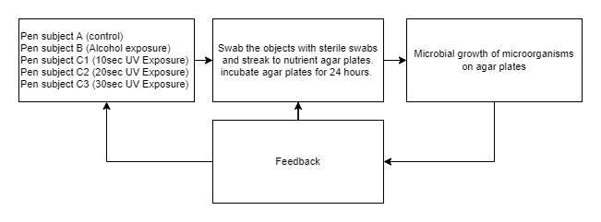

Figure 5: Conceptual Framework

**Statement of the Problem**

This study aims to determine the effectiveness of ultra violet lights in disinfecting using an automatic disinfection box.

Specifically, the study sought to find the answers to the following questions:

1. What is the significant difference between ultraviolet-based disinfectant and alcohol-based disinfectant in terms of their effectiveness?
2. What is the significant effect of ultraviolet intensity to be use in terms of its effectiveness?
3. What is the significant difference among the different duration in terms of its effectiveness?
4. 10 seconds

3

1. 20 seconds
2. 30 seconds
3. How does the automatic disinfection box be described in terms of?

a) Necessity

b) Quality

c) Price-quality ratio

d) Approval

**Hypothesis**

The researchers lead up to the following hypothesis.

There is no significant difference between ultraviolet-based disinfectant and alcohol-based disinfectant in terms of their effectiveness, there is no significant effect of ultraviolet intensity to be use in terms of its effectiveness and there is no significant difference among the duration of 10 seconds, 20 seconds, and 30 seconds in terms of its effectiveness. The automatic disinfection box does not meet current pandemic situation extremely well, the automatic disinfection box has a very low quality, the price of automatic disinfection box has a poor value for money and the respondents are very dissatisfied using the automatic disinfection box.

**Scope and Limitations of the Study**

The device will have a dimension of 72cm in height, 84cm in length, and 54cm in width. The entrance clearance of the frame will have a dimension of 68cm in height and 78cm in width. The device will have a PIR sensor to detect if and object is ready inside the device.

The study will be limited to the comparison of effectiveness of ultraviolet-based disinfection with alcohol-based (70% alcohol content, isopropyl) disinfection, determining if there’s a significant effect of ultraviolet intensity to be use in terms of its effectiveness, determining the significant difference among the duration of 10 seconds, 20 seconds, and 30 seconds in terms of its effectiveness, and determining the overall user rating of the device in terms of necessity, quality, price-quality ratio and approval.

The study will be limited to the effect of automatic disinfection box using ultra violet light on microbial growth of microorganisms, not determining the specimen that grow on the nutrient agar, and not determining the UVC dosage and irradiance of the automatic disinfection box.

The target specimen in the experiment is/are unidentified. The specimen will not be identified from the nutrient agar.

The study will not cover the comparisons of effectiveness of ultraviolet-based disinfection and specific brands of alcohol. The study will not cover the comparisons of the effectiveness of ultraviolet-based disinfection and different alcohol content (beside 70% alcohol content) of specific brands of alcohol.

**Significance of the Study**

The Corona Virus Disease 2019 pandemic has increased the need for human disinfection. It is important to avoid reducing transmission risk. Thorough and efficient disinfection procedures must be implemented to return to our day-to-day operations cost-effectively.

Cognizant of the growing problem of stress, this study will be significant to the following:

1. **To health and safety officers** - automated disinfection promotes contactless, safe and good social distancing practice.

To help health and safety officers in maximization of time, effort, and funding in implementing health protocols by hastening and achieving optimal hygiene.

1. **To the user** – contactless disinfection

5

To maintain proper hygiene with minimal contact, skin problems (e.g. drying), reduce hassle and space consumption (e.g. hand washing area) and achieve a higher level of disinfection.

1. **To the environment** – less plastic waste residue, reusable.

To help reduce plastic and waste residues from alcohol plastic containers. Moreover, it helps reduce wastewater and water pollution.

1. **To the future researchers** – serves as good foundation of contactless. automatic and innovative method of disinfection.

This innovation will provide greater insight into the potentials of automated innovation specifically in the maximization of materials, reduce human error, and increase efficacy rate.

1. **To shipping companies** – the device can provide an extra level of protection for their employees. As a shipping company employee, you will handle different objects and parcels every day at many quantities. This device can add an additional layer of protection to their protocol that will further lessen the probability of infection towards their employees and even towards the people that will deliver them and those who will receive them.
2. **To parcel couriers** – this will provide reassurance to their customers as this device will make them feel at ease because they will be informed that not only are the couriers finished their vaccine shots, but the parcel they also carry will be disinfected even before they get to them.
3. **To bulk buyers** – they can safely use the products they will purchase safely. This will be valuable for them because it will be very hard to disinfect products one by one if they buy them in large quantities. This will not only ease the workload of the buyers, but also protect them and their possible customers from harmful microorganisms.

**Definition of Terms**

The following key terms used in this study are defined for the purpose of clarification.

1. **Excimer lamps**. Ultraviolet light produced by spontaneous production of excimer molecules.
2. **Genotoxicity**. Cancer leading mutations cause by damaging genetic information.
3. **In vitro**. Artificial environment

6

1. **Staphylococcus aureus**. Primary leading cause of skin and soft tissue infections such as abscesses (boils), furuncles, and cellulitis.

**Chapter 2**

**REVIEW OF LITERATURE AND STUDIES**

This chapter contains documents, books, findings, academic and research journals that is related to the research.

**Ultraviolet Disinfection**

According to Childress J. (2021), the 254-nm UV light and 222-nm UV are germicidal light wavelengths that inactivate bacteria and viruses. Like standard 254-nm UVC, 222-nm UV light breaks the DNA bonds inside a microbe’s nucleus, which can prevent microbes from replicating. Furthermore, 222-nm UV is highly absorbed by protein bonds in the membrane shells of microbes and human cells. This protein interaction makes 222-nm light effective at defeating microbes and much safer than 254-nm UV for human exposure. The data indicates that 222-nm light is much safer for humans than 254-nm light. This can allow 222-nm UV to be safely used when humans are present.

According to Childress J. (2021), Not all UV light is the same. Some UV wavelengths are better than others at disinfection, and some are safer for humans. Invisible to the human eye, UV is light at wavelengths shorter than 400 nm and greater than 100 nm. The UV spectrum is broken into sub-bands of UVA, UVB, and UVC. The UVA waveband is nearly visible and commonly called black light. UVB, a slightly shorter wavelength, is a major factor in getting sunburned and can cause skin cancer. Both UVA and UVB easily enter the earth’s atmosphere and are present in sunlight. On the other hand, the UVC wavelengths, which are shorter than UVB, are blocked by the ozone in the earth’s upper atmosphere and not typically present in sunlight at the earth’s surface. This is important for germicidal effectiveness because it means microbes have fewer defenses against the shorter UVC wavelengths. Even within this UVC band, not all light is the same. According to studies at Columbia, UV light at the 222-nm wavelength has similar germicidal capabilities of the more widely used 254-nm UV light to kill or inactivate microbes (bacteria and viruses), but it does not produce the same damaging effects on skin or eyes as 254-nm light. This improved safety is because the shorter 222-nm UV wavelength has reduced penetration depth in human tissue. While the negative effects on humans are reduced, 222-nm light has increased performance for killing some bacteria and viruses.

According to Childress J. (2021), the output intensity of the 222 nm lamp can be varied by changing the input power, allowing the lamp to be instantly brightened or dimmed as required. Depending on design, excimer lamps can be run at power levels from as low as a few watts to kilowatts. To improve human safety even further, an optical filter can be added to remove small amounts of harmful wavelengths that might also have been generated above 230 nm.

Light from UVC systems is absorbed by DNA. The absorption of UVC by the DNA of a virus or bacteria damages its DNA, preventing the microbe from replicating. A microbe that cannot make copies of itself cannot cause harm. The 254-nm UV is highly absorbed by DNA but not easily absorbed by protein. This means that 254-nm light penetrates deeper into layers of protein-rich skin cells. While 254-nm UV damages microbe DNA, it can also penetrate deeper into human skin and damage the DNA of actively dividing skin cells. Damaged DNA in actively dividing human cells can lead to cancer (Childress J., 2021).

8

Furthermore, the 222-nm UV, on the other hand, is highly absorbed by both proteins and DNA. The outer membrane shell of all bacteria and viruses contains protein. Thus, 222-nm UV interacts not only with the DNA of the microbe but also the outer membrane shell of the microbes. Compared to 254-nm UVC, this dual mechanism of both DNA damage and protein shell interaction can increase the effectiveness of 222-nm UV against some microbes. It also makes it safer for humans.

All cells are rich in protein. Since 222-nm light is highly absorbed by protein, it cannot penetrate very far into thick layers of cells. The 222-nm light will fully penetrate viruses and bacteria but cannot penetrate the thick protein-rich outer layer of the skin, which is composed of dead skin cells. The outer layer of dead skin cells contains no active cells and much thicker than the largest bacteria or virus. This layer acts as an armor against 222-nm light. A similar outer protection layer of cells, the tear layer, protects the eyes. This makes 222-nm UV much safer for humans because the 222-nm light never reaches the DNA of active cells dividing inside the body. Since the 222-nm light does not reach actively dividing cells, it cannot cause cancer.

According to Geiger, the Duke Health researchers are using a portable machine called “Tru-D SmartUVC” to disinfect rooms of the patients. They have observed that there are bacteria that remained inside the patient rooms because of the patient that carried the organism inside the room. These bacteria are harmful because it can also affect the next patients that will occupy the same room. They have proven the effectivity of the usage of UVC lights using their portable machine as it not only disinfects patient rooms from viruses, they can also eradicate superbugs such as MRSA or Methicillin-resistant Staphylococcus aureus.

9

According to a study by Nozomi et al. (2020), 222-nm UVC lamps can be safely used for sterilizing human skin as far as the perspective of skin cancer development. Germicidal lamps that emit primarily 254 nm ultraviolet radiation (UV) are routinely utilized for surface sterilization but cannot be used for human skin because they cause genotoxicity. As an alternative, 222-nm UVC has been reported to exert sterilizing ability comparable to that of 254-nm UVC without producing cyclobutane pyrimidine dimers (CPDs), the major DNA lesions caused by UV. However, there has been no clear evidence for safety in chronic exposure to skin, particularly with respect to carcinogenesis. Nozomi et al investigated the long-term effects of 222-nm UVC on skin using highly photocarcinogenic phenotype mice that lack xeroderma pigmentosum complementation group A (Xpa-) gene, which is involved in repairing of CPDs. CPDs formation was recognized only uppermost layer of epidermis even with high dose of 222-nm UVC exposure. No tumors were observed in Xpa-knockout mice and wild-type mice by repetitive irradiation with 222-nm UVC, using a protocol which had shown to produce tumor in Xpa-knockout mice irradiated with broad-band UVB. Furthermore, erythema and ear swelling were not observed in both genotype mice following 222-nm UVC exposure.

According to Buonanno et al. (2020), a direct approach to limit airborne viral transmissions is to inactivate them within a short time of their production. Germicidal ultraviolet light, typically at 254 nm, is effective in this context but, used directly, can be a health hazard to skin and eyes. By contrast, far-UVC light (207–222 nm) efficiently kills pathogens potentially without harm to exposed human tissues. to Buonanno et al. (2020) demonstrated that 222-nm far-UVC light efficiently kills airborne influenza virus and we extend those studies to explore far-UVC efficacy against airborne human coronaviruses alpha HCoV-229E and beta HCoV-OC43. Low doses of 1.7 and 1.2 mJ/cm2 inactivated 99.9% of aerosolized coronavirus 229E and OC43, respectively. As all human coronaviruses have similar genomic sizes, far-UVC light would be expected to show similar inactivation efficiency against other human coronaviruses including SARS-CoV-2. Based on the beta-HCoV-OC43 results, continuous far-UVC exposure in occupied public locations at the current regulatory exposure limit (~3 mJ/cm2/hour) would result in ~90% viral inactivation in ~8 minutes, 95% in ~11 minutes, 99% in ~16 minutes and 99.9% inactivation in ~25 minutes. Thus, while staying within current regulatory dose limits, low-dose-rate far-UVC exposure can potentially safely provide a major reduction in the ambient level of airborne coronaviruses in occupied public locations.

10

According Kitagawa et al. (2020), the effectiveness of 222-nm UVC irradiation on viable SARS-CoV-2 suggest that this technology could be used for infection prevention and control against COVID-19, not only in unoccupied spaces but also occupied spaces.

Severe acute respiratory syndrome coronavirus 2 (SARS-CoV-2), which causes coronavirus disease 2019 (COVID-19), has emerged as a serious threat to human health worldwide. Efficient disinfection of surfaces contaminated with SARS-CoV-2 may help prevent its spread. Kitagawa et al. (2020) aimed to investigate the in vitro efficacy of 222-nm far-ultraviolet light (UVC) on the disinfection of SARS-CoV-2 surface contamination.

Kitagawa et al. (2020) investigated the titer of SARS-CoV-2 after UV irradiation (0.1 mW/cm2) at 222 nm for 10-300 seconds using the 50% tissue culture infectious dose (TCID50). In addition, they used quantitative reverse transcription polymerase chain reaction to quantify SARS-CoV-2 RNA under the same conditions.

11

One and 3 mJ/cm2 of 222-nm UVC irradiation (0.1 mW/cm2 for 10 and 30 seconds) resulted in 88.5 and 99.7% reduction of viable SARS-CoV-2 based on the TCID50 assay, respectively. In contrast, the copy number of SARS-CoV-2 RNA did not change after UVC irradiation even after a 5-minute irradiation.

The study shows the efficacy of 222-nm UVC irradiation against SARS-CoV-2 contamination in an in vitro

McLeod (2020)

According to Buonnano et al., the exposure of 222nm can efficiently and safely inactivate the coronaviruses that will then become harmless for human interaction. It is said in their study that 254 nm is used more often in disinfecting coronavirus but can be harmful for humans due to its radiation. They demonstrated that 222 nm of UVC light can also efficiently inactivate the virus but is less harmful to humans unlike 254 nm. 1.7 and 1.2 mJ/c^2 doses of the 222 nm inactivated 99.9% of the aerosol coronaviruses and other human coronaviruses like SARS-CoV 2.

According to Garcia et al., UV-C (Ultraviolet C) lights are proven to sanitize different surfaces reached by the said lighting and can also eradicate different viruses and bacteria such as escherichia coli. With only 10 minutes of exposure to the said light with the intensity of 0.15 - 0.4 W/m^2, it is proven to remove harmful bacteria such as e-coli. UV-C is capable of inactivating the bacteria within the 167cm distance from the UV-C lamp. Though UV-C was proven and tested to sanitize surfaces from dangerous bacteria, the researchers said that the application of manual sanitation will make the UV-C lights most effective.

12

Based on the “Guidelines on UV Disinfection” by the Philippine Dermatology Society, the usage of UVGI (Ultraviolet Germicidal Irradiation) has captured the interests of different groups in efforts of reducing the spread of infection that transfers itself to another host by the means of touching or getting exposed to an infected item wherein a person uses or interacts a device or item that a Covid-19 infected person has previously used. UVGI is currently being used to disinfect the air and surfaces in the attempt of providing extra precaution to people given that PPEs (Personal Protective Equipment) are not enough for the people working in the medical fields. Although UV exposure being dangerous to a person is a fact, with proper dilution of the radiation, it can be used to eradicate viruses at a microscopic level. With a dosage of 0.5 - 1.8 J/cm^2, viruses such as influenza (H1N1, H5N1, H7N9), MERS-CoV, and SARS-CoV are proven and tested to be disinfected and has little to no effect to other people. Though such viruses can be disinfected with only 0.5 J/cm^2, other authors urged the need to use at least 1 J/cm^2 on all surfaces to ensure the safety of the medical workers and prevent any exposure to lingering viruses attached to a surface.

According to Ramos et al. (2020), Because of its efficiency as a germicidal agent, UV-C has been proven to be a useful addition to terminal manual cleaning. More research is needed to establish a safe exposure dose standard, particularly for 222 nm germicidal lamps. Any targeted deployment of UV-C during the Coronavirus Disease 2019 (COVID-19) epidemic requires direct evidence.

According to Miranda et al. (2020) there has been research on the effectiveness of land mobile devices using UV technology in removing and deactivating pathogenic germs from contaminated surfaces in public areas by 60%. Only 40% of the studies included in this review found insufficient scientific evidence to establish the impact of UV technology on disease control in affected areas. This leads to the conclusion that there is enough research on the positive usage of this sort of technology in the control of contaminated area disinfection.

13

According to Eubania et al. (2021) Various UV-C lamps and Pulsed Xenon UVC (PX-UV) lamps were utilized in twelve research, including one cluster RCT, seven quasi-experimental studies, and four uncontrolled before and after studies. Because of research design flaws, imprecision, and a significant likelihood of bias, the overall certainty of evidence from these 12 studies was rated low.Only one study found a 44% decrease in viral infections among pediatric patients at that clinic. In ten of the 12 studies, UV-C was found to be an effective supplement to existing cleaning techniques, with the latter proving to be significantly more effective at eradicating bacteria

Deoxyribonucleic Acid (DNA) and Ribonucleic Acid (RNA) are the genetic materials that make up all living organisms. These are responsible for controlling the growth, development, functioning, and the reproduction of these organisms. These acids that make up all living organisms can be damaged by UV radiation. UV or Ultraviolet radiation produces electromagnetic energy that can disrupt an organism’s ability to reproduce and when prolonged exposure occurs, it can lead to permanent inactivation and can lead to either mutation or cell death (VioletDefense.com).

According to Ploydaeng et al., since mid 18-th century, there have been studies relating to UV-C lights and their capacity to prevent microbial growth. UV-C lights are mostly absorbed by DNA and RNA of an organism which can make them unable to produce and will eventually lead to mutation and/or cell death. The radiation frequently causes thymine and cytosine, two pyrimidine nucleoside bases, to cross-link and become non-pairing bases in the same DNA strand. Cyclobutyl pyrimidine dimers are the most prevalent photoproducts in DNA (CPD). By interfering with DNA replication, transcription, and translation, this product impairs cellular activity, which in turn causes bacterial cell death and viral inactivation.

MDR or Multidrug-Resistant Pathogens are one of the reasons why there are certain increases in mortality rates. The number of these pathogens is significant to the increase of deaths because these make it harder for professionals to cure their patients when they are inflicted with these pathogens that are resistant to drugs such as antibiotics. Researchers Yang et al. conducted a research regarding these pathogens and their reaction towards UV-C lights especially to those MDR pathogens that are common in hospital areas. They exposed MDR-Pseudomonas aeruginosa, MDR- Acinetobacter baumannii, methicillin-resistant Staphylococcus aureus (MRSA), vancomycin-resistant Enterococcus faecium (VRE), Mycobacterium abscessus and Aspergillus fumigatus to UV-C lights and observed if there will be an effect to these pathogens. The research concluded that UV-C light can deactivate and kill these MDR pathogens after the 15-minute-long exposure to UV-C light.

**Ultraviolet Disinfection Machines**

Paras E. (2020), created a device called Parazap, a portable Ultraviolet room disinfection unit that is electrically operated. The device is designed to disinfect PPEs, specifically N95 masks, killing almost 99% of microorganisms by means of exposure to ultraviolet (UV) radiation. It consists of two sets of UV-C germicidal lamps having 15 and 18-wattage and can accommodate up to10 N95 masks in one cycle. The UV-C chamber can also be adjusted according to duration of exposure – from 60seconds to 60 minutes depending on the prescribed length of exposure to kill a certain type of microorganism. All of the materials in making the equipment were locally available.

Zakaria F. (2016), studied Ultraviolet germicidal (short wavelength UV-C) light as surface disinfectant in an Emergency Sanitation Operation System® smart toilet to aid to the work of manual cleaning. The UV-C light was installed and regulated as a self-cleaning feature of the toilet, which automatically irradiate after each toilet use. Two experimental phases were conducted i.e., preparatory phase consists of tests under laboratory conditions and field-testing phase. The laboratory UV test indicated that irradiation for 10 min with medium–low intensity of 0.15–0.4 W/m2 could achieve 6.5 log removal of Escherichia coli. Field testing of the toilet under real usage found that UV-C irradiation was capable to inactivate total coliform at toilet surfaces within 167-cm distance from the UV-C lamp (UV-C dose between 1.88 and 2.74 mW). UV-C irradiation is most effective with the support of effective manual cleaning. Application of UV-C for surface disinfection in emergency toilets could potentially reduce public health risks.

14

**Streak Plate Method**

According to Dahal (2022), the streak plate method is a microbiological culture technique where a sample is spread in a petri dish in the form of a long, thin line over the surface of solid media. The objectives of the streak plate method is to obtain a pure culture of bacteria from a mixed culture, obtain well-isolated colonies and propagate bacteria.

The streak plate method relies on dilution to produce well-isolated colonies of the sample at the terminal streaks during the mechanical spreading of inoculum over the surface of solidified culture media.

Sample can be either colony on solid media or suspension in broth. The most common tool used to collect the sample is a sterile inoculating loop or swab. A smear is created by placing the sample over a sterile solid media surface at the petri dish's edge. The smear is successively streaked over the agar media using the instrument in various patterns. The inoculum is gradually diluted as the streaking process goes on, resulting in the separation of bacterial cells as individual cells or as colony-forming units (CFU) at a spacing of a few millimeters. These inoculation plates will produce a well-isolated colony when they are incubated with the isolated bacterium or CFU. This will enable us to obtain a pure culture and define the organism's colony form.

**Spread Plate Method**

According to Dahal (2022), “The spread plate method is a microbiological laboratory technique for isolating and counting the viable microorganisms present in a liquid sample by spreading a certain volume of the sample over an appropriate solidified culture media”.

In a successful spread plate, distinct colonies will emerge after incubation in an even distribution throughout the surface of the culture media.This method is used to isolate and count all colony-forming units per milliliter (CFU/mL) of viable bacteria present in the sample. It also serves as a means of mass producing the outdated culture. It works with every culturable fungus and bacterium.

The objectives of spread plate plate method is to isolate the microorganisms from the liquid specimen (or suspension), calculate viable microbial load by counting colony formation unit (CFU) per mL, isolate the pure culture of microorganisms from a mixed population, isolate microorganisms in discrete colonies in order to study their colony characters and obtain sufficient growth for conducting antimicrobial sensitivity testing and biochemical studies (Dahal, 2022).

**Kirby Bauer Disc Diffusion Method for Antibiotic Susceptibility Testing**

According to Sharma (2022), “Kirby Bauer tests also known as the Disc diffusion test is used for antibiotic susceptibility testing”. The test is performed to determine the sensitivity or resistivity of aerobes or facultatively anaerobes against different classes of antibiotics. The aim of the method is to aid physicians to assist in selecting treatment options and to determine the ability of antibiotics to inhibit the organisms.

**UVC Direct Exposure**

According to the U.S Food & Drug Administration (2022), there are also limitations to how effective UVC radiation can be at inactivating viruses, generally.UVC radiation can only inactivate a virus if the virus is directly exposed to the radiation. Therefore, the inactivation of viruses on surfaces may not be effective due to blocking of the UV radiation by soil, such as dust, or other contaminants such as bodily fluids. Many of the UVC lamps sold for home use are of low dose, so it may take longer exposure to a given surface area to potentially provide effective inactivation of a bacteria or virus.

UVC radiation is commonly used inside air ducts to disinfect the air. This is the safest way to employ UVC radiation because direct UVC exposure to human skin or eyes may cause injuries, and installation of UVC within an air duct is less likely to cause exposure to skin and eyes.There have been reports of skin and eye burns resulting from improper installation of UVC lamps in rooms that humans can occupy.

**UVC Exposure Risks**

According to the FDA (2022), UVC radiation can cause severe burns of the skin and eye injuries (photokeratitis). Skin burns and eye injuries from UVC exposure usually resolve within a week with no known long-term damage. Since the penetration depth of UVC radiation is very low, the risk of skin cancer, cataracts or permanent vision loss is also thought to be very low. The type of eye injury associated with exposure to UVC causes severe pain and a feeling of having sand in the eyes. Sometimes people are unable to use their eyes for one to two days. It can occur after a very short exposure (seconds to minutes) to UVC radiation.

Risks associated with using some UVC lamps

According to the FDA (2022), some UVC lamps emit small amounts of UVB radiation. Therefore, exposure to a high dose or prolonged low dose of radiation from some UVC lamps can potentially contribute to effects like cataracts or skin cancer that are caused by cumulative exposure to UVB radiation.

Additionally, some UVC lamps generate ozone which could cause irritation to breathing passages (that is nose, throat, and lungs), particularly for those who have respiratory sensitivity such as asthma or allergies. Exposure to high levels of ozone gas may also worsen chronic respiratory diseases, such as asthma, or increase vulnerability to respiratory infection.

According to the FDA (2020), UVA and UVB rays can cause damage to the skin. Sunburn is a sign of short-term overexposure, while premature aging and skin cancer are side effects of prolonged UV exposure.

**Time to Inactivate Microorganisms**

According to the Americanultraviolet (2022), the effectiveness of UVC light is based on the variables of time or the length of exposure, intensity of the source, and the distance or how far the source is from the target. Different microorganisms require various levels of UVC for inactivation and it rest on how the bacterial cell is built.

**UV-C Penetrable Plastic & Materials**

According to Kosta G. (2020), short wave UV (UVC) cannot pass through most plastics or ordinary glass. Most acrylic plastics do not allow UV-C wavelengths (100-280 nm) to penetrate. Also, very thin acrylic sheets of below 5 millimeters do not let UVC light penetrate.

In addition, suitable transparent media do not exist anymore, limiting the choices to reflective optics such as Highly purified calcium fluoride(CaF2), Magnesium Fluoride (MgF2), Lithium Fluoride (LiF). UV-grade fused silica, Artificial diamond and Borate crystals.

**FYL201 Lamp**

According to felcostore (2022), the FYL201 disinfects, sterilizes, kills bacteria, germs and viruses, coronavirus, influenza virus, mites, anthrax, Hepa B, and dysentery bacteria. The FYL201 disinfecs e-coli, staphylococcus aureus, candida albicans, pseudomonas aeruginosa.

The FYL201 is a quartz lamp cap, filament core, mercury pill lamp type with a UVC length of 254nm. It has an operating voltage of 230V - 60Hz. With an 15-20 sqm coverage area and a dimension of 624 x 48 x 70mm (felcostore, 2022).

According to the Americanultraviolet (2022), Germicidal UVC lamps do not produce much heat and about the same as fluorescent lamps. fluorescent lamps don’t use resistance to emit light, they emit about 75% less heat than an incandescent bulb. As a result, they save energy and keep whatever room they’re in at a cooler temperature.

**Beam Angle**

According to lampphq (2022), the beam angle determines the diameter of the generated light circle on the illuminated surface or object. The ideal beam angle usually depends very individually on the place of use of the lamp and on your own use-case. Large beam angles of 90° or 120° are well suited for illuminating a room over a large area. Small beam angles of 15° to 35° are a good choice for decorative lighting.

**Disinfection Distance**

According to felcostore (2022), FYL201 has a coverage area of 15-20 sqm. Using the beam angle formula, we can calculate the beam angle to determine the diameter of the object or the effective illuminated surface.

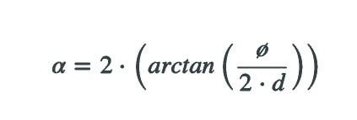

Where:

• α: Beam angle

• Ø: Diameter of the object or surface to be illuminated

• d: Distance between lamp and object or surface

• arctan: Inverse function of the tangent for angle calculation

by inserting values to the formula, the effective spot light diameter of the automatic disinfection box is 4.5 ft. By reducing the distance of the illuminated object from the lamp, the illuminated object remains inside the 100% intensity area.

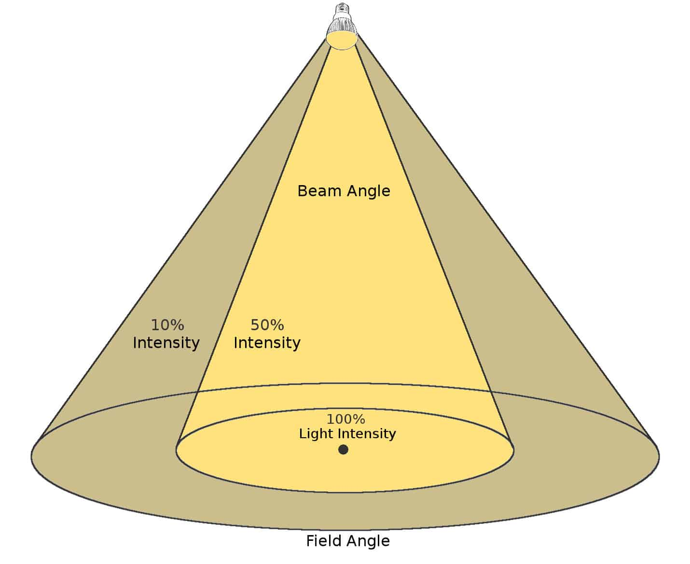

Following considerations for a beam angle, the beam angle of 120 degrees of the lamp has a very good diffusion of light for the automatic disinfection box.

**Synthesis of the Reviewed Literature and Studies**

Since 222-nm light is both deadly to microbes and safer for humans, it has the potential to be used in applications where humans are present during UV disinfection while still remaining within government UV exposure guidelines. The 222-nm lights can be installed in ceilings or walls and turned on when needed for disinfection. The UV lamp installation can be as large as a fluorescent light or as small as a smoke detector, depending on the desired speed of disinfection. The applications are limitless. A few examples include health facilities, visitor areas, office areas, food service areas, lavatories, and transport vehicles of all types (Figure 5). Almost any communal space can benefit from safe and effective disinfection that is automatic and uses no chemicals. Indicating the potential of 222-nm UV disinfection.

15

**Chapter 3**

**METHODOLOGY**

This chapter contains research design, methods and diagrams that will be used in the study.

**Research Design**

The researchers use quantitative experimental research design for statement of the problem 1 to 3 in the study. According to Bhandari 2021, quantitative experimental research systematically tests causal relationships, collect and analyze numerical data and generalize results. Qualitative research design is used for statement of the problem 4a to 4d. According to Acasestudy (2020),” Qualitative research targets on conveying meaning and comprehension via detailed description”. The research designs will be used in the study.

Two-Samples Wilcoxon Test, One-Sample Wilcoxon Test, Kruskal-Walis Test, Four-point Likert scale are used for the statistical analysis of the study. Spread plate and streak plate microbiological culture technique are used in the field experiment. The alcohol sample for the experiment is 70% isopropyl alcohol.

**Flowchart of Research Design/Process Flowchart**

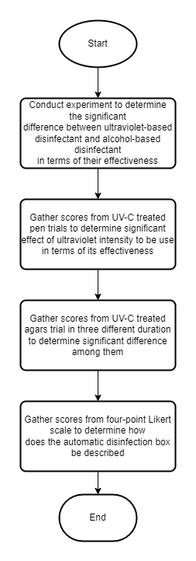

Figure 6: Research Design Flowchart

**Description of Research Instrument Used**

According to Cuevas R. V (2022), The unpaired two-samples Wilcoxon test is a non-parametric alternative to the unpaired two-samples t-test that can be used to compare two independent sets of samples. It is utilized when the data are not regularly distributed.

When the data cannot be assumed to be normally distributed, the one-sample Wilcoxon signed rank test is a non-parametric alternative to the one-sample t-test. It is used to determine whether the sample's median equals a recognized standard value or theoretical value (Cuevas R. V, 2022)

According Cuevas R. V (2022), The Kruskal-Wallis H test or one-way ANOVA is a rank-based nonparametric test that can be used to determine if there are statistically significant differences between two or more groups of an independent variable on a continuous or ordinal dependent variable.

The four-point Likert scale are used to assess the opinions of the respondets.

**Statistical Treatment**

The Two-Samples Wilcoxon Test are used in statement of the problem 1 to determine the significant difference between ultraviolet-based disinfectant and alcohol-based disinfectant in terms of their effectiveness. One-Sample Wilcoxon Test are used in statement of the problem 2 to determine the significant effect of ultraviolet intensity to be use in terms of its effectiveness. Kruskal-Walis Test are used in the statement of the problem 3 to determine the significant difference among the different duration in terms of its effectiveness. The four-point Likert scale are used in statement of the problem 4a – 4d to allow participant to express how much they agree or disagree with the particular statement.

**Material Requirements**

The material gathered for the experiment are premixed nutrient agar (35g), sterile disposable petri plates (9cmx1.5cm), medical cotton swab, cling wrap,L-shaped rod, paper filter punchlets, distilled water, 70% isopropyl alcohol and the automatic disinfection box.

**Field Experiment**

Four similar pens are prepared a day before and equally exposed to normal condition. Nutrient agar is prepared by adding 17.5g of premixed nutrient agar and 482.5mL of distilled water to obtain 500g agar solution. The solution is mixed and bring to a boil. After 5mins of non-stop stirring, the pot is removed from the heat to cool poured the solution to jars and pressured cook for 45mins at 15psi. The jars are removed from the pressure cooker, let it cool to 50 C and poured to prepared petri dishes. Five agar plates with three replications are prepared. Agar plate A (control), plate B (Alcohol exposure), plate C1 (10sec UV exposure), plate C2 (20sec UV exposure) and plate C3 (30sec UV exposure).

For plate A, pen 1 is not exposed to alcohol and UV disinfection. Using sterile medical swab, pen 1 surface is swab. After the hardening of the agar, using streak plate method, the agar is swab with it. The plate is secured then with cling wrap. The same procedure is done with the replications.

For plate B, pen 1 is swab with sterile L-shaped rod, using the rod, agar plate is prepared using spread plate technique. After the hardening of the agar, four paper filter punchlets soaked in 70% isopropyl alcohol are put to the four quadrants of the agar (disk diffusion method). The same procedure is done for the replications.

For plate C1, pen 2 is disinfected using the automatic disinfection for 10 seconds. Using sterile medical swab, the surface of the pen is swab. The plate C1 is swab using streak plate technique. The plate is secured with cling wrap. The same procedure was done with the replications.

For plate C2, pen 3 is disinfected using the automatic disinfection for 20 seconds. Using sterile medical swab, the surface of the pen is swab. The plate C2 is swab using streak plate technique. The plate is secured with cling wrap. The same procedure was done with the replications.

For plate C3, pen 4 is disinfected using the automatic disinfection for 30 seconds. Using sterile medical swab, the surface of the pen is swab. The plate C3 is swab using streak plate technique. The plate is secured with cling wrap. The same procedure was done with the replications.

**Chapter 4**

**PRESENTATION, ANALYSIS AND INTERPRETATION OF DATA**

This chapter includes the presentation of the proposed system from components to detailed procedure, analysis of the data gathered from the research design, and the interpretation of data.

**Components of the Proposed System**

The researchers’ components of the proposed system are Arduino uno r3 for microcontroller board. AC relay module kit with outlet plug and wire for Arduino control of 220v AC load, 10 ohms and 100 ohms resistors, passive infrared sensor, I2C LCD display 16x2, GSM module, sim900 GPRS shield, wire, 5v power supply and FYL201 germicidal UV tube.

**System Implementation (Hardware)**

The model development stage consists stages of modeling, design and analysis. The researchers study different sanitation chamber, ultra violet chamber and sanitation device. The researchers ponder that the chamber must have the capability and strength to hold and sanitize objects with size of at least 50cm in height and width. After studying different sanitation chamber models and considering the researchers requirements, the researchers come up with the following model dimension. 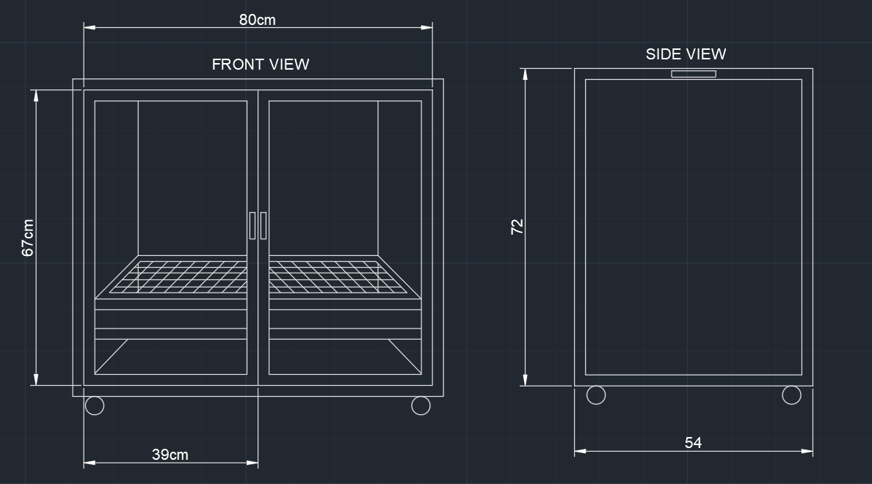

The researcher’s requirement must have also that the device is mobile and have the capability to move around effortlessly. the device must also have the capability to smoothly insert objects inside the chamber. The device must also conform to quality standards and have the capability to blend to commercial sanitation chambers in market. The researchers come up with the following model design.

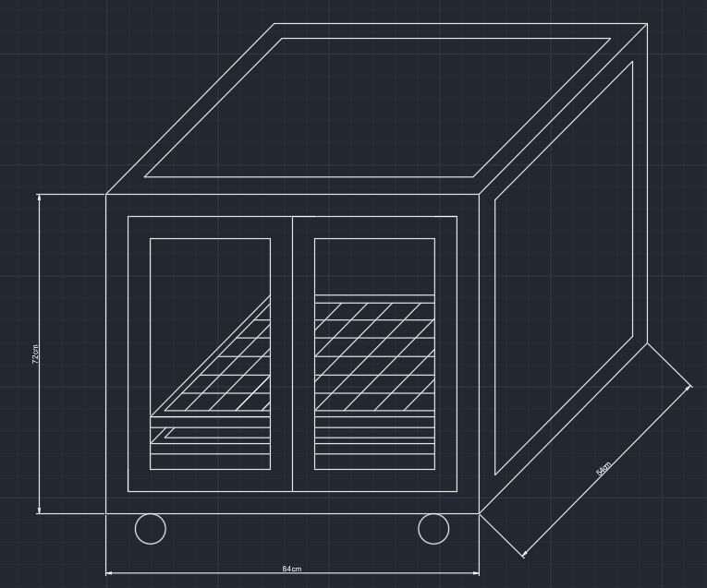Lastly, the design analysis data will be gathered from the survey to be conducted. Specifically, how does the automatic disinfection box be described in terms of necessity, quality, price-quality ratio and approval.

**Materials and Specifications**

The following are the materials used for the disinfection box.

L- bracket or angle bar ¼ x 1 in size. Galvanized steel sheet with measurement of 4x8 in .9 thickness. Flat steel bars. Nylon caster wheels (swivel). Galvanized steel matting. ¼ thick clear glass. Stainless cabinet handle. Cylindrical hinges 3/8. Roller catches. Glass silicone sealant. Teks screw. Reflective Insulation foam. Rugby glue. Aerosol paint color white and clear for coating

**Detailed Procedure (Hardware)**

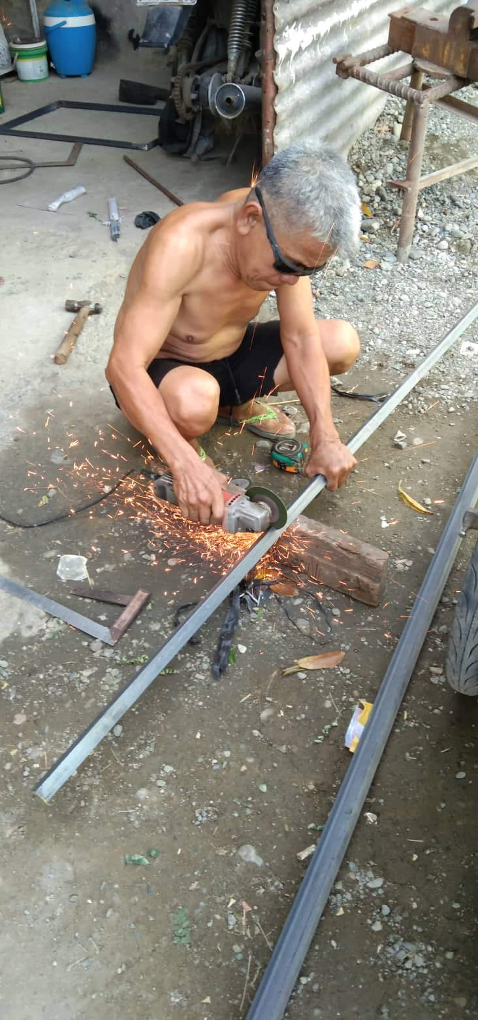

Angle bars with measurement each of 72, 84 and 54cm. are prepared using angle grinder. A welding machine is use to weld the pieces together into the shape of the frame.

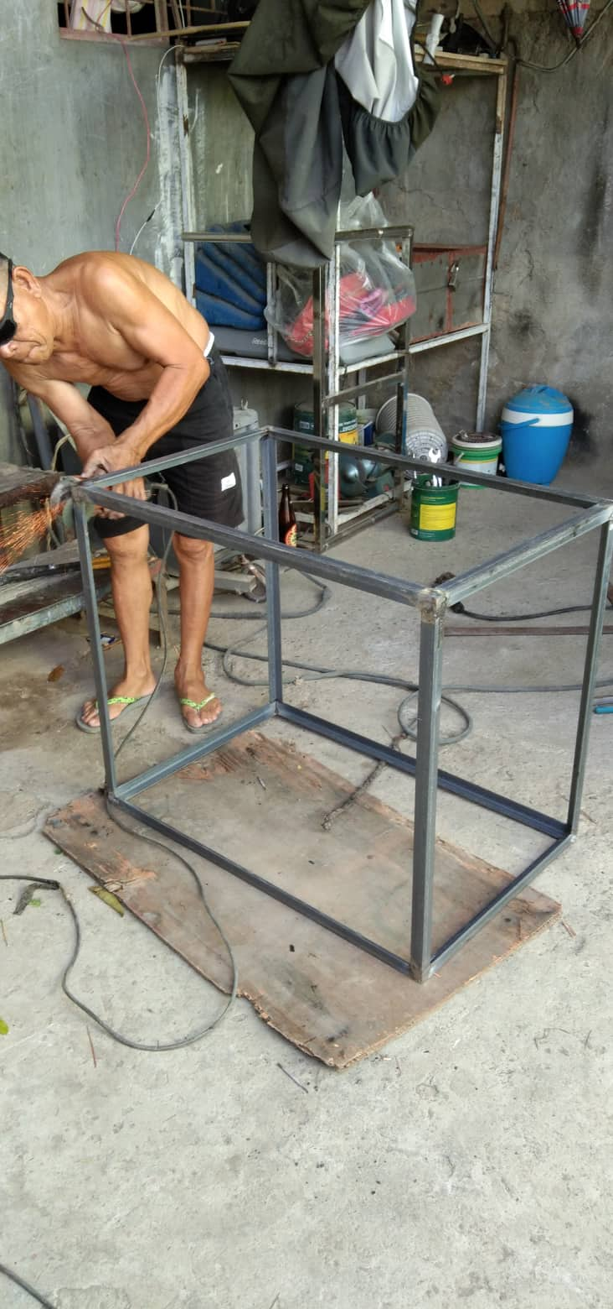

Having the rigid frame, the frame is turned upside down to weld the caster wheels on each corner of the frame as to give the frame maneuverability.

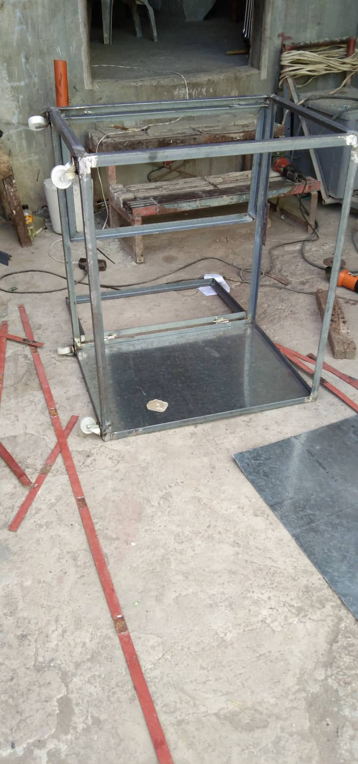

A 39 and 67cm angle bars are prepared using the angle grinder and welded into shape of a door frame.

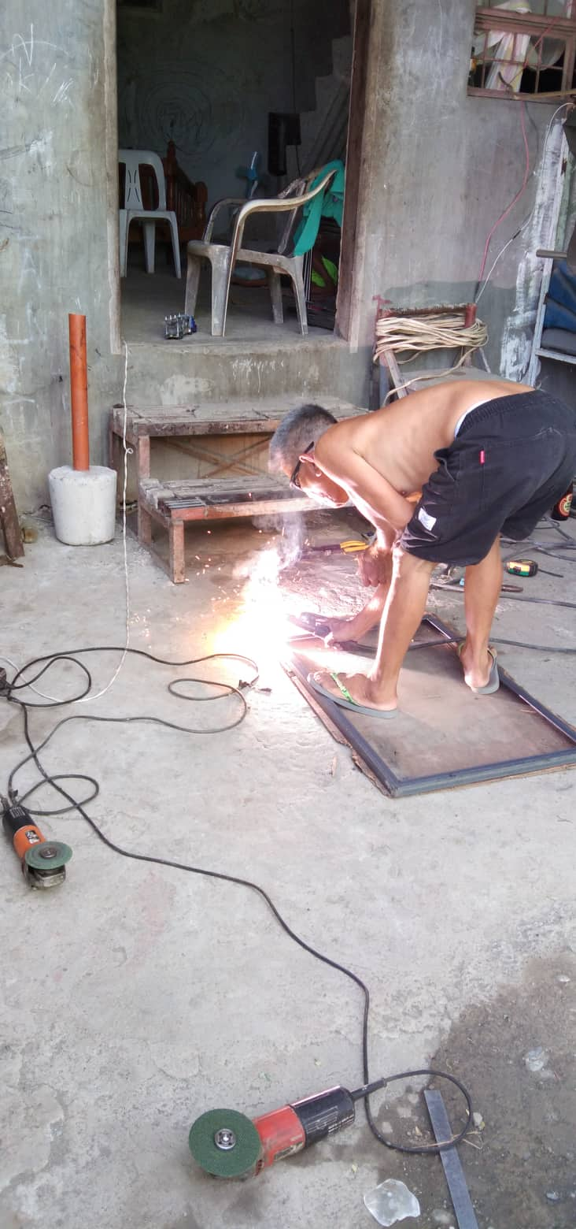

The door was fixed to the frame using cylindrical hinges. Roller catches are fixed onto the front top and bottom center of the frame.

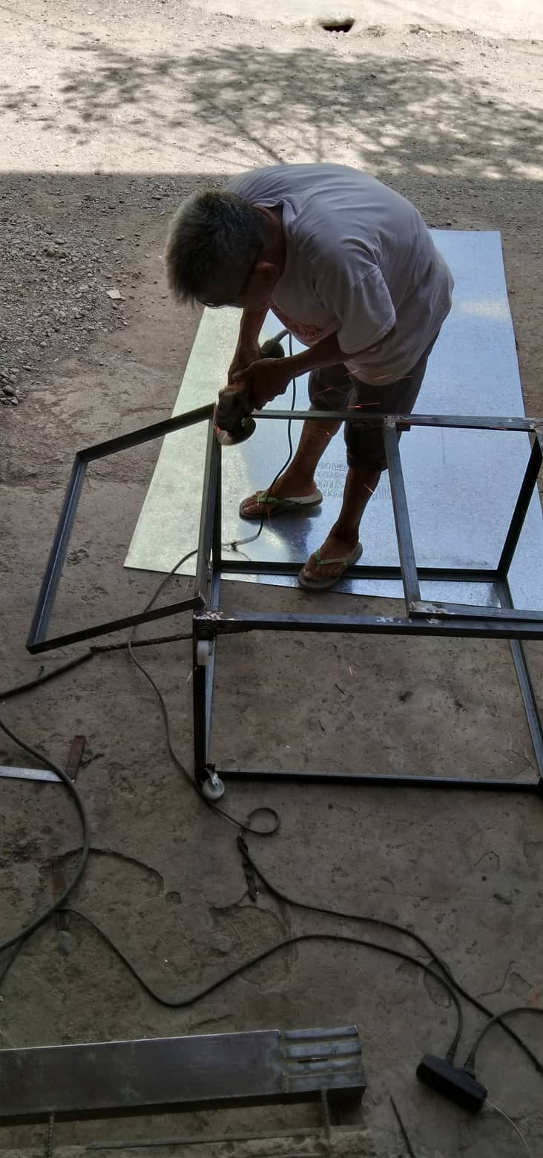

After turning the frame upright, galvanized steel walls are cut and prepared. Using the welding machine, the steel walls are fixed onto the frame reinforcing with flat bars.

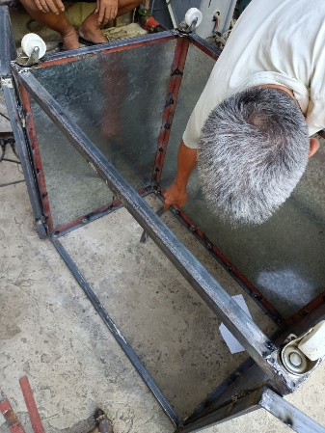

Using a measuring tape to have the center of the door frame, two holes were drilled. The aluminum handle bars are screwed onto the frame. Using the same technique, two holes were drilled on the side of the frame and aluminum handle bars are fixed using screws onto the frame.

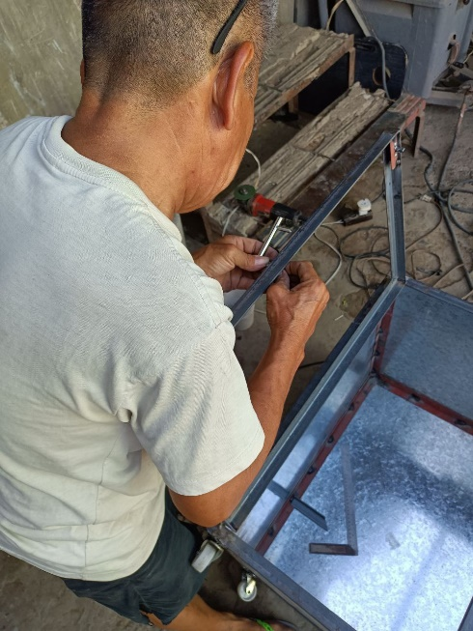

Using the angle grinder, the frame was sanded off of sharp edges. After smoothing the frame, using aerosol paint, a white coat was applied inside and outside the frame.

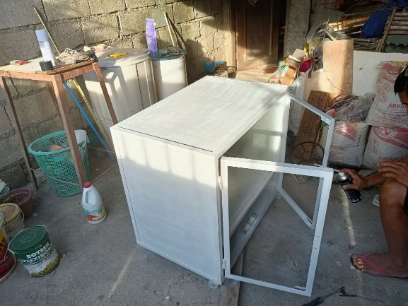

A clear coat was applied after drying of the primer. A two 49 and 81cm angle bar are prepared and welded into a shape of rectangle and galvanized wire mesh are cut accordingly to the dimension and welded onto the shape. The mesh, who serves as the object holder are coated with primer and clear coat also.

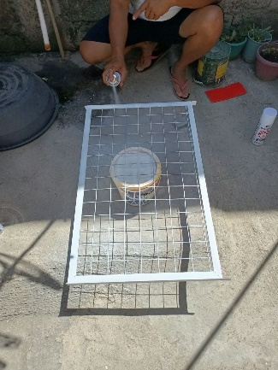

The wire mesh and the circuit chamber divider are fixed onto the inside of the frame using teks screw.

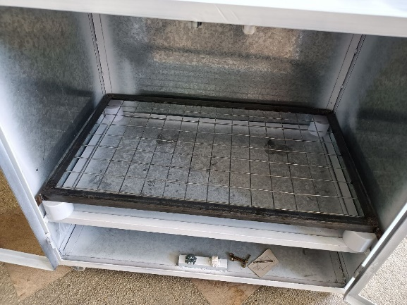

¼ inch thick clear glass are fixed onto the door frame using glass silicon putty.

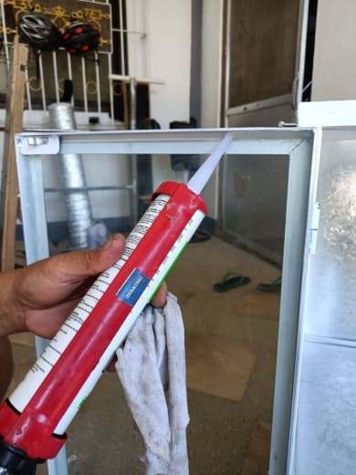

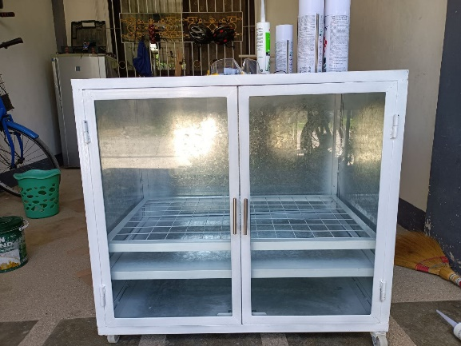

**Block Diagram**

The figure below shows the block diagram of the circuit.

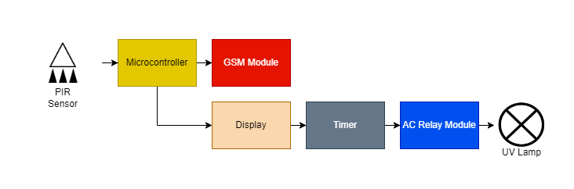

**Flow Chart**

The figure below shows the flowchart of the circuit.

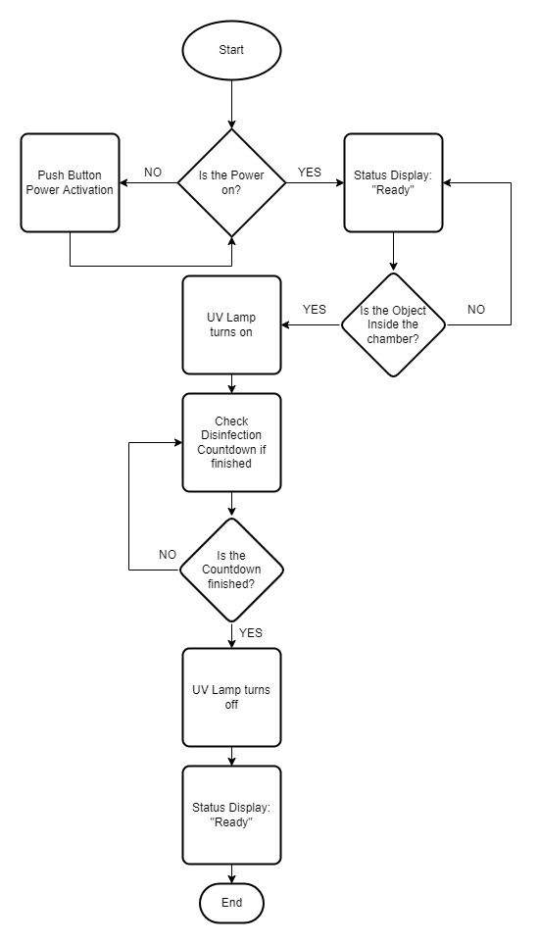

**Source Code**

The following program statements shows the source code of the device.

#include <Wire.h>

#include <SoftwareSerial.h>

#include <LiquidCrystal_I2C.h>

SoftwareSerial mySerial(9,10);

char msg;

char call;

LiquidCrystal_I2C lcd(0x27, 16, 2);

int ledPin = 3;

int buzzer = 2;

byte zero[] = {

B00000,

B00000,

B00000,

B00000,

B00000,

B00000,

B00000,

B00000

};

byte one[] = {

B10000,

B10000,

B10000,

B10000,

B10000,

B10000,

B10000,

B10000

};

byte two[] = {

B11000,

B11000,

B11000,

B11000,

B11000,

B11000,

B11000,

B11000

};

byte three[] = {

B11100,

B11100,

B11100,

B11100,

B11100,

B11100,

B11100,

B11100

};

byte four[] = {

B11110,

B11110,

B11110,

B11110,

B11110,

B11110,

B11110,

B11110

};

byte five[] = {

B11111,

B11111,

B11111,

B11111,

B11111,

B11111,

B11111,

B11111

};

void setup(){

digitalWrite(4, HIGH);

delay(1000);

digitalWrite(4, LOW);

delay(5000);

lcd.init();

lcd.backlight();

digitalWrite(ledPin, HIGH);

pinMode(ledPin, OUTPUT);

pinMode (buzzer, OUTPUT);

lcd.createChar(0, zero);

lcd.createChar(1, one);

lcd.createChar(2, two);

lcd.createChar(3, three);

lcd.createChar(4, four);

lcd.createChar(5, five);

mySerial.begin(9600);

Serial.begin(9600);

}

void loop(){

int pirState=digitalRead(6);

if (pirState == LOW){

lcd.setCursor(0,0);

lcd.print("PUT OBJECT");

lcd.setCursor(0,1);

lcd.print("TO DISINFECT");

delay(500);

}

else if (pirState == HIGH){

delay(3000);

lcd.clear();

lcd.setCursor(0,0);

lcd.print("DISINFECTING:");

delay(500);

digitalWrite(ledPin, LOW);

for(int i=0; i <= 100; i++)

{

lcd.setCursor(0,1);

updateProgressBar(i, 100, 1);

delay(100);

}

delay(1000);

lcd.clear();

lcd.setCursor(0,0);

lcd.print("DONE!!!!");

digitalWrite(ledPin, HIGH);

digitalWrite(buzzer, HIGH);

delay(1000);

digitalWrite(buzzer, LOW);

delay(1000);

digitalWrite(buzzer, HIGH);

delay(1000);

digitalWrite(buzzer, LOW);

delay(1000);

digitalWrite(buzzer, HIGH);

delay(1000);

digitalWrite(buzzer, LOW);

SendMessage();

lcd.clear();

lcd.setCursor(0,0);

lcd.print("DISINFECTION");

lcd.setCursor(0,1);

lcd.print("COMPLETE");

delay(2000);

lcd.clear();

lcd.setCursor(0,0);

lcd.print("PLEASE REMOVE");

lcd.setCursor(0,1);

lcd.print("OBJECT NOW 5");

delay(1000);

lcd.setCursor(0,0);

lcd.print("PLEASE REMOVE");

lcd.setCursor(0,1);

lcd.print("OBJECT NOW 4");

delay(1000);

lcd.setCursor(0,0);

lcd.print("PLEASE REMOVE");

lcd.setCursor(0,1);

lcd.print("OBJECT NOW 3");

delay(1000);

lcd.setCursor(0,0);

lcd.print("PLEASE REMOVE");

lcd.setCursor(0,1);

lcd.print("OBJECT NOW 2");

delay(1000);

lcd.setCursor(0,0);

lcd.print("PLEASE REMOVE");

lcd.setCursor(0,1);

lcd.print("OBJECT NOW 1");

delay(1000);

lcd.setCursor(0,0);

lcd.print("PLEASE REMOVE");

lcd.setCursor(0,1);

lcd.print("OBJECT NOW 0");

delay(1000);

lcd.clear();

digitalWrite(pirState, LOW);

delay(5000);

}

}

void updateProgressBar(unsigned long count, unsigned long totalCount, int lineToPrintOn)

{

double factor = totalCount/80.0;

int percent = (count+1)/factor;

int number = percent/5;

int remainder = percent%5;

if(number > 0)

{

lcd.setCursor(number-1,lineToPrintOn);

lcd.write(5);

}

lcd.setCursor(number,lineToPrintOn);

lcd.write(remainder);

}

void SendMessage()

{

mySerial.println("AT+CMGF=1");

delay(1000);

mySerial.println("AT+CMGS=\"+639750710500\"\r");

delay(1000);

mySerial.println("DISINFECTED");

delay(100);

mySerial.println((char)26);

delay(1000);

}

**Component Analysis**

The researchers’ components of the proposed system are Arduino uno r3 for microcontroller board. AC relay module kit with outlet plug and wire for Arduino control of 220v AC load, 10 ohms and 100 ohms resistors, passive infrared sensor, a I2C LED display 16x2 IC2, GSM module, sim900 GPRS shield, wire, 5v power supply and Firefly Yellow Shield Antivirus and Germicidal UV Tube Set.

Arduino Uno R3 is a 14 input/output pinned microcontroller which has a 16-Megahertz ceramic resonator, USB connection, a power jack, an ICSP header and a reset button. This is a microcontroller that can be programmed and as such, can be the only microcontroller you will ever need in creating complicated systems.

Arduino Uno can only handle up to 5 volts and can malfunction when applied at a higher voltage, much more when using 220 AC volts into it. The AC Relay module kit helps the microcontroller to handle up to said voltage that is in the description of the module. In the module used in the project, the researchers specifically used a 220v AC load.

Resistors are static components that help regulate the current running in a circuit. The higher the resistance(ohms), the lesser the current(amp). In the project, the researchers specifically used 10 ohms and 100 ohms values of resistors.

Passive Infrared Sensors or PIR Sensors is used to detect an object that is in front of it and act as a switch to a circuit. It activates the circuit when the object is detected by the infrared. This is commonly used in automatically triggered lighting devices and protection systems. In the project, the researchers used it as a detector for the object or item placed inside the chamber to automatically start the disinfection process.

LED Displays are displays that are commercially used in the market because of their efficiency and low-energy consumption. These displays are made up of a series of LED panels which contain LEDs that can be used in a variety of ways from providing light to sending a message. The researchers used a Grove, 16x2 LED display which can be programmed with the use of Arduino Uno and is used to display the status of the disinfection process.

GSM (Global System for Mobile Communications) Module is a chip that can be used to provide the option to send SMS (short messages service) messages in a system. This chip has an antenna to receive and send out transmissions and a slot for the sim card which will be used to send out messages to other devices. The sim900 GPRS shield is the specific model used by the researchers. Despite the small size of the model, this packs many features and is one of the latest models.

The circuit created by the researchers is connected by copper wires. Copper wires are most commonly used in circuits for its conductivity and these wires are covered by rubber for insulation.

Power supplies are components that supply power to at least one load. This is used to provide and regulate a consistent value of current to a load to avoid any inconsistency to the load that can cause complications and malfunctions for the load. The researchers used specifically a 5v power supply that is used to supply power to the Arduino Uno.

UV lights are lights that are capable of disinfecting surfaces within a prolonged period of time under a specific range of intensities. The researchers used Firefly Yellow Shield Antivirus and Germicidal UV Tube Set which has an intensity of 254 nm, operates at a 230 V at 60 Hz, and covers the range of 15 to 20 square meters.

**Schematic Diagram**

The figure below shows the schematic diagram of the circuit.

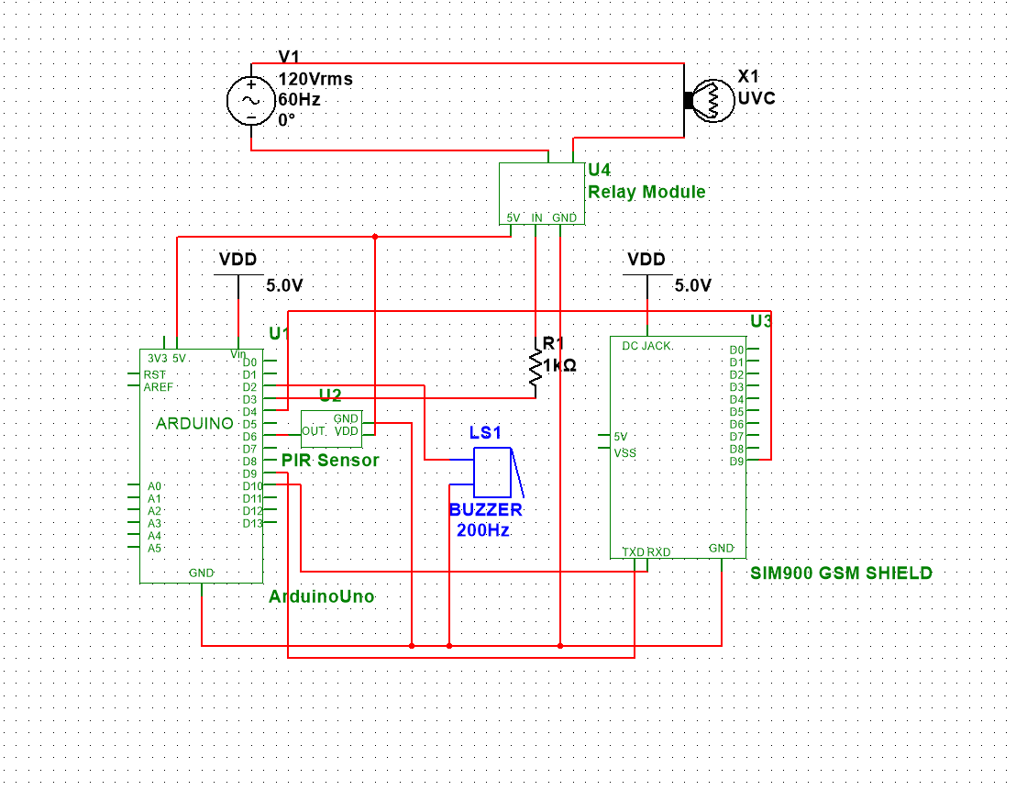

**Fabrication of the Device**

Connect the GND pins of PIR Sensor, Buzzer, SIM900, and Relay Module to the GND pin of Arduino. Then, connect the source pin of PIR Sensor and Relay Module to the 5V pin of Arduino. After that, connect the TXD and RXD pins of SIM900 to pins 9 and 10 of Arduino respectively. Connect pin 2 of Arduino to the positive pin of the buzzer, then connect the OUT pin of PIR Sensor to pin 6 of Arduino. After that, connect the pin 9 of SIM900 to pin 4 of Arduino. And then connect the pin 3 of Arduino to a 1k resistor then connect the other end of the resistor to the IN pin of Relay Module. Lastly, connect an AC source to the relay module to power up the UVC lamp.

The circuit is soldered in a printed circuit board and placed in the circuit box of the automatic disinfection box.

**Functionality Testing**

Initialized the automatic disinfection box by turning on the power source of the device. After initializing the LCD Display will show a message to put an object to disinfect. Put the subject on the sanitation chamber. After disinfecting the subject for 10 seconds, an SMS will be sent to the registered number that the subject has been disinfected. Remove the subject from the sanitation chamber, after 5 seconds, the device is ready for use again.

**Field Experiment and Survey Results**

**Field Experiment**

The following shows the analysis report of the field experiment.

legends:

a(1-3) – control

b(1-3) – alcohol

c1 – 10 sec UV

c2 – 20 sec UV

c3 – 30 sec UV

|  |  |  |  |  |  |
| --- | --- | --- | --- | --- | --- |
| Agar Plate | Microbiological Culture Technique | No. of  Colonies | Colony Average | Colony Size Average (cm) | Zone of Inhibition Average |
| A1 | Streak Plate Method | 44 | 22.66 | 0.36 |  |
| A2 | 7 |  |
| A3 | 17 |  |
|  |  |  |  |  |  |
| B1 | Spread Plate Method | 9 | 9.66 | 0.193 | 0.681 cm |
| B2 | 13 |
| B3 | 7 |
|  |  |  |  |  |  |
| C1 | Streak Plate Method | 6 | 4.33 | 0.126 |  |
| C1 | 5 |  |
| C1 | 2 |  |
|  |  |  |  |  |  |
| C2 | Streak Plate Method | 4 | 3.66 | 0.1 |  |
| C2 | 3 |  |
| C2 | 4 |  |
|  |  |  |  |  |  |
| C3 | Streak Plate Method | 3 | 2.33 | 0.87 |  |
| C3 | 2 |  |
| C3 | 2 |  |

Agar plate A1 with microbial culture technique of streak plate method produce 44 colonies. Plate A2 produce 7 colonies and A3 produce 17 colonies. The Three replication produce an average of 22.66 colonies with an average colony size of 0.35 cm.

Agar plate B1 with microbial culture technique of spread plate method produce 9 colonies. Plate B2 produce 13 colonies and B3 produce 7 colonies. The Three replication produce an average of 9.66 colonies with an average colony size of 0.193 cm with a zone of inhibition average of 0.681 cm.

Agar plate C1 with microbial culture technique of streak plate method produce 6 colonies. Replication 2 produce 5 colonies and replication 3 produce 2 colonies. The Three replication produce an average of 4.33 colonies with an average colony size of 0.126 cm.

Agar plate C2 with microbial culture technique of streak plate method produce 4 colonies. Replication 2 produce 3 colonies and replication 3 produce 4 colonies. The Three replication produce an average of 3.66 colonies with an average colony size of 0.1 cm.

Agar plate C3 with microbial culture technique of streak plate method produce 3 colonies. Replication 2 produce 2 colonies and replication 3 produce 2 colonies. The Three replication produce an average of 2.33 colonies with an average colony size of 0.87 cm.

**Survey Results**

The table below shows the mean of the responses on each statement of the problem.

|  |  |  |  |  |
| --- | --- | --- | --- | --- |
|  | **Necessity**  **(SOP4a)** | **Quality**  **(SOP 4b)** | **Price-Quality Ratio**  **(SOP 4c)** | **Approval**  **(SOP 4d)** |
| **Mean** | 1.36 | 1.43 | 2.15 | 1.49 |
| **Overall Mean** | 1.61 |  |  |  |
| **Respondents** | 114 |  |  |  |

The statement of the problem 4a yields a response mean of 1.36, statement of the problem 4b yields a response mean of 1.43, statement of the problem 4c yields a response mean of 2.15 and statement of the problem 4d yields a response mean of 1.49.

**Chapter 5**

**SUMMARY OF FINDINGS, CONCLUSION AND RECOMMENDATIONS**

This chapter presents the summary of the findings, conclusion and the recommendations on how to improve the study.

**Summary of Findings**

**Statistical Analysis of UV Based and Alcohol Disinfectant Data**

All statistical analyses were performed using R Studio v 4.2.1 and all test of significance were evaluated at 5% level.

Effectiveness of UV based and Alcohol based disinfectant were measured based on number of colonies in different treatments. Different treatments were replicated thrice and were compared to a baseline treatment wherein the agar plate was not exposed to UV or Alcohol. Results revealed that the baseline treatment was relatively higher compared to Alcohol based and UV based treatments. This suggests that Alcohol based and UV based disinfectant were more effective in terms of bacterial inhibition.

**Statement of the Problem 1**

What is the significant difference between ultraviolet-based disinfectant and alcohol-based disinfectant in terms of their effectiveness?

**Null Hypothesis:** There is no significant difference between UV based disinfectant and Alcohol based disinfectant in terms of their effectiveness.

**Alternative Hypothesis:** There is a significant difference between UV based disinfectant and Alcohol based disinfectant in terms of their effectiveness.

**Result of Two-Samples Wilcoxon Test**

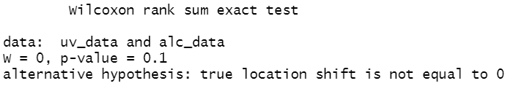

**Conclusion**

Since the p-value of 0.1 is greater than 5% level of significance (0.05), there is enough evidence to conclude that UV and Alcohol based disinfectant exhibit no significant difference when it comes to their effectiveness.

**Statement of the Problem 2**

What is the significant effect of ultraviolet intensity to be use in terms of its effectiveness?

**Null Hypothesis:** There is no significant effect of UV intensity to be use in terms of effectiveness.

**Alternative Hypothesis:** There is a significant effect of UV intensity to be use in terms of effectiveness.

**Result of One-Sample Wilcoxon Test**

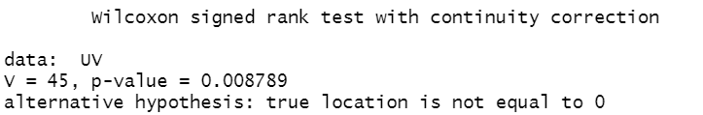

**Conclusion**

Since the One-Sample Wilcoxon Test resulted a p-value of 0.0088, and is less than 5% level of significance (0.05), it was therefore concluded that UV intensity has a significant effect in terms of effectiveness. This result supports the comparison of findings of Baseline treatment and UV based treatments in terms of bacterial inhibition since number of colonies from UV based treatments were lower than those from the former.

**Statement of the Problem 3**

What is the significant difference among the different duration in terms of its effectiveness?

**Null Hypothesis:** There is no significant difference among the duration of 10 seconds, 20 seconds, and 30 seconds in terms of its effectiveness.

**Alternative Hypothesis:** There is a significant difference among the duration of 10 seconds, 20 seconds, and 30 seconds in terms of its effectiveness.

**Result of Kruskal-Walis Test**

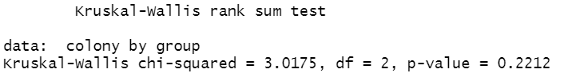

**Conclusion**

Since the Kruskal-Walis test yields a p-value of 0.2212, and is greater than 5% level of significance (0.05), therefore, the different durations of UV exposure show no significant difference in terms of effectiveness.

The researchers use convenience sampling as a non-probability sampling method due to resource limitation in collecting feedback. The method yields a total 114 responses.

The researchers adapt Cuevas R. V (2022) four-point Likert scale, where value one leans to strongly agree and value four leaning to strongly disagree.

The table below shows the verbal descriptions of the values.

|  |  |  |  |  |  |
| --- | --- | --- | --- | --- | --- |
|  |  | **Verbal Descriptions** | | | |
| **Values** | **Statistical Range (mean)** | **SOP 4a** | **SOP 4b** | **SOP 4c** | **SOP 4d** |
| 1 | 1 - 1.74 | Extremely Well | Very High Quality | Excellent | Very Satisfied |
| 2 | 1.75 - 2.49 | Very Well | High Quality | Above Average | Somewhat Satisfied |
| 3 | 2.5 - 3.24 | Not So Well | Low Quality | Below Average | Somewhat Dissatisfied |
| 4 | 3.25 - 4 | Not at all Well | Very Low Quality | Poor | Very Dissatisfied |

The four-point Likert scale have statistical range of (1 – 1.74) for value 1. (1.75 - 2.49) for value 2. (2.5 - 3.24

) For value 3 and (3.25 - 4) for value 4.

The following computation obtains the statistical range.

**Max – Min = R**

4 – 1 = 3

**R / Max = Q**

¾ = 0.75

**Q + Min = Lower Limit**

lower Limits = 1, 1.75, 2.5, 3.25

**Lower Limit – 0.01 = Upper Limit**

1.75 - 0.01 = 1.74

**Next Upper Limit**

1.74 + 0.75 = 2.49

2.49 + 0.75 = 3.24

3.24 + 0.75 = 4

**Statistical analysis of Four-point Likert Scale**

The following table shows the statistical mean of the responses.

|  |  |  |  |  |
| --- | --- | --- | --- | --- |
|  | **Necessity**  **(SOP4a)** | **Quality**  **(SOP 4b)** | **Price-Quality Ratio**  **(SOP 4c)** | **Approval**  **(SOP 4d)** |
| **Mean** | 1.36 | 1.43 | 2.15 | 1.49 |
|  | Extremely Well | Very High Quality | Above Average | Very Satisfied |
| **Overall Mean** | 1.61 |  |  |  |
| **Respondents** | 114 |  |  |  |

In terms of necessity, the mean 1.36 falls in the statistical range of 1 – 1.74. The Pie graph below shows the graphical representation of the response percentage.

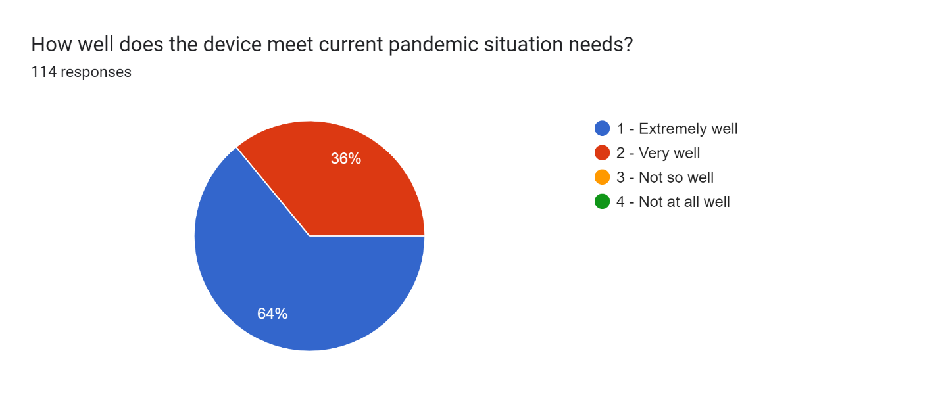

In terms of quality, the mean 1.43 falls in the statistical range of 1 - 1.74. The Pie graph below shows the graphical representation of the response percentage.

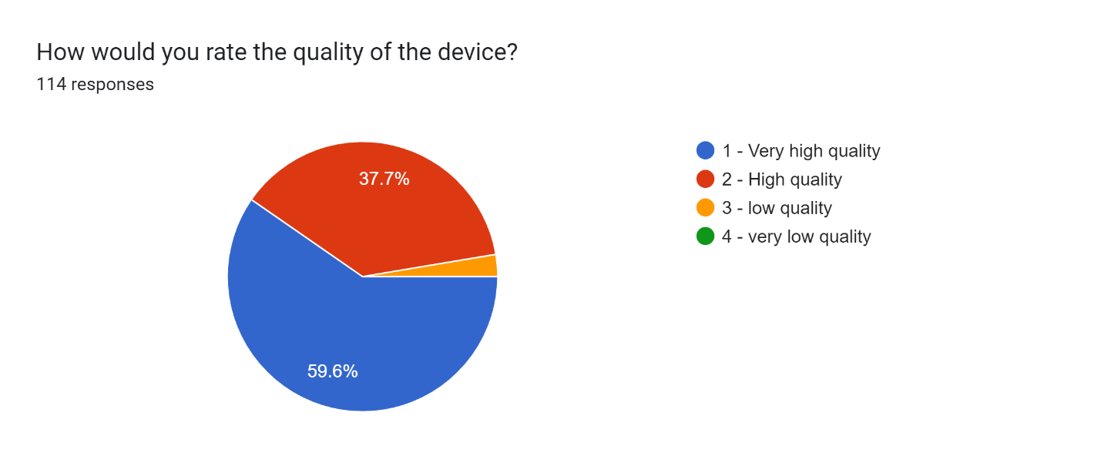

In terms of price-quality ratio, the mean 2.15 falls in the statistical range of 1.75 - 2.49. The Pie graph shows the graphical representation of the response percentage.

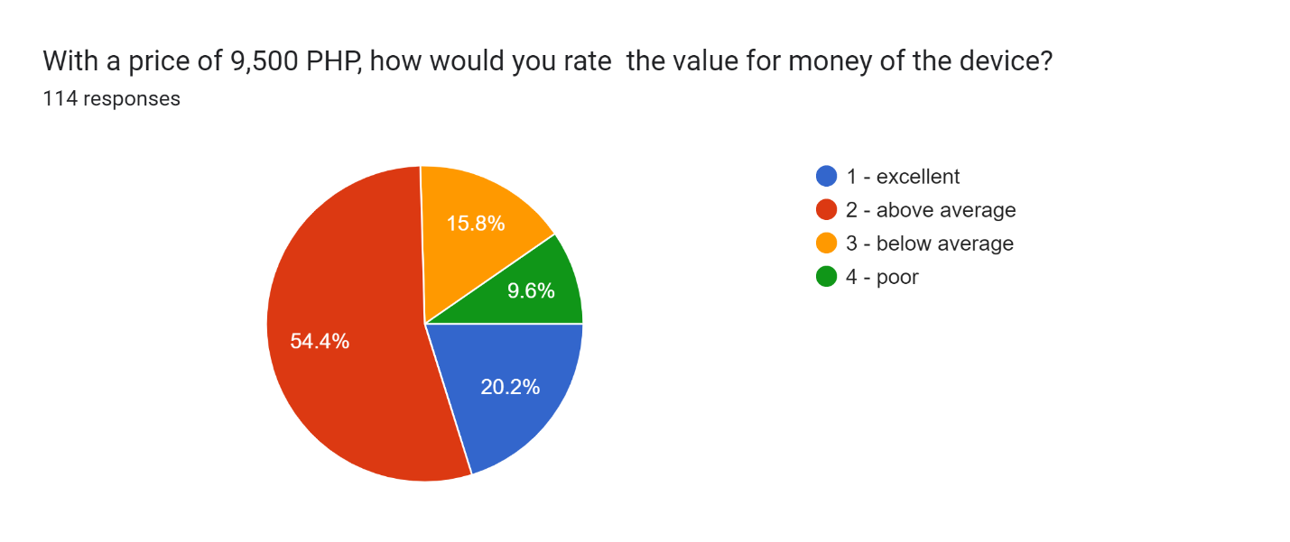in terms of approval, the mean 1.49 falls in the statistical range of 1 – 1.74. The Pie graph below shows the graphical representation of the response percentage. 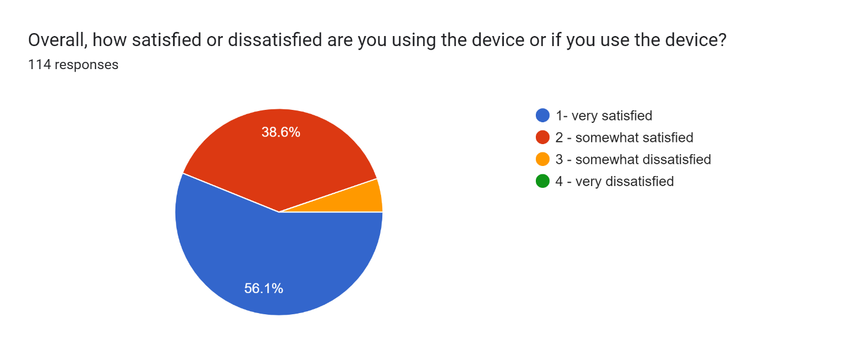

**Conclusions**

The following conclusion were made based on the findings:

There is enough evidence to conclude that UV and Alcohol based disinfectant exhibit no significant difference when it comes to their effectiveness. UV intensity has a significant effect in terms of effectiveness and this result supports the comparison of findings of Baseline treatment and UV based treatments in terms of bacterial inhibition since number of colonies from UV based treatments were lower than those from the former, and the different durations of UV exposure of 10, 20, 30 seconds show no significant difference in terms of effectiveness.

Based on the statistical analysis, the automatic disinfection meets current pandemic situation extremely well, the automatic disinfection box has a very high quality in terms of quality, have an above average price-quality price ratio and the respondents are very satisfied using the automatic disinfection box.

**Recommendations**

The researchers conducted this project with the aim to innovate a way to integrate the functionality of UV C light which is to prevent the growth of microorganisms or even completely disable them into a chamber wherein an item will be placed inside and will be automatically disinfected through a sensor that will activate the light and expose the item in a specific duration of time. In this project, the researchers encountered difficulties and other functionalities that could be added to the device that will further develop the versatility of the device. These features and solutions that could be added to the device are as follows:

1. Although there has been a test that proved the usage of UV C light can debilitate microorganisms, the researchers failed to measure the exact level of intensity the light emitted. A way to monitor the intensity of the light could be added to the device that can be used to observe the level of radiation the device produces which can tell the users if it is underperforming or exceeds the safety level the light should be emitting.

2. Even though the researchers thought of a way to monitor the health of the device, a counter for the device’s health can make the status of the device easier to discern even for random users.

3. Currently, the device can create messages to a mobile phone to inform the user of the item being disinfected the status of the disinfection process. It can only send a “DISINFECTED” message to a single mobile phone. The researchers can further expand this functionality by adding a numpad module which can allow the user to input their own mobile phone number where the device is going to send the message. The length of the message can also be improved by adding more information to the message.

4. The mobile application of the project can be improved by adding an admin and user interface. Adding these increases the possible functionalities that can be added to the device like controlling it and monitoring its status only by using the application.

These improvements and possible functionalities stated are encountered by the researchers during the creation of the device and the integration of the modules and functionalities into it. The researchers are unable to add these functionalities due to limitations like the constraints of time.

**References**

Barnard, I. R. M., E. Eadie, and K. Wood. “Further Evidence That Far-UVC for Disinfection Is Unlikely to Cause Erythema or Pre-Mutagenic DNA Lesions in Skin.” Photodermatol Photoimmunol Photomed, 1111/phpp.12580, 2020, Retrieved from https://doi.org/10.1111/phpp.12580.

Bhandari P. (2020). An introduction to quantitative research. Retrieved from <https://www.scribbr.com/methodology/quantitative-research/>

Brenner, D. J. “Far-UVC Light to Limit Airborne Transmission of SARS-CoV-2 … and All Other Viruses.” The Second Gilbert W. Beebe Webinar: Safety and Efficacy of UVC to Fight Covid-19, National Academies of Sciences, Engineering, and Medicine: Washington, DC, 16 September 2020, Retrieved from https://www.nationalacademies.org/event/09-16-2020/the-second-gilbert-w-beebe-webinar-safety-and-efficacy-of-uvc-to-fight-covid-19.

Buonanno, M. (2020, December 23). Far-UVC light (222ânm) efficiently and safely inactivates airborne human coronaviruses. Scientific Reports. Retrieved from https://www.nature.com/articles/s41598-020-67211-2

Buonanno, M., B. Ponnaiya, D. Welch, et al. “Germicidal Efficacy and Mammalian Skin Safety of 222-nm UV Light.” Res., vol. 187, no. 4, pp. 483–491, 2017, Retrieved from https://doi.org/10.1667/RR0010CC.1.

Buonanno, M., D. Welch, I. Shuryak, and D. J. Brenner. “Far-UVC Light (222 nm) Efficiently and Safely Inactivates Airborne Human Coronaviruses.” Rep., vol. 10, no. 1, p. 10285, 24 June 2020, Retrieved from https://doi.org/10.1038/s41598-020-67211-2.

Childress J. (March 22, 2021). Using 222-nm Ultraviolet (UV) Light for Safer Disinfection. Retrieved from https://www.dsiac.org/resources/articles/using-222-nm-ultraviolet-uv-light-for-safer-disinfection/

DOST (May 22, 2020). DOST-X, PARAS JOIN HANDS IN DEVELOPING PARAZAP DISINFECTION UNIT FOR COVID-19. Retrieved from https://www.dost.gov.ph/knowledge-resources/news/67-2020-news/1823-dost-x-paras-join-hands-in-developing-parazap-disinfection-unit-for-covid-19.html

Effectiveness of UV-C light irradiation on disinfection of an eSOSÂ® smart toilet evaluated in a temporary settlement in the Philippines. (2016). Taylor & Francis. Retrieved from https://www.tandfonline.com/doi/abs/10.1080/09603123.2016.1217313

Eubanas, G. A., De Dios, N., & Bayona, H. H. (2021, February 26). Are ultraviolet lamps effective in infection prevention and control of COVID-19 infections in public spaces in locations with sustained community transmission? Https://Www.Psmid.Org. Retrieved from https://www.psmid.org/wp-content/uploads/2021/04/NPI_UV-Lamps_20210405.pdf

Fiona Zakaria, Bertin Harelimana, Josip Ćurko, Jack van de Vossenberg, Hector A. Garcia, Christine Maria Hooijmans & Damir Brdjanovic (2016) Effectiveness of UV-C light irradiation on disinfection of an eSOS® smart toilet evaluated in a temporary settlement in the Philippines, International Journal of Environmental Health Research, 26:5-6, 536-553, DOI: 10.1080/09603123.2016.1217313

Geiger, D. (2020). UV Light Helps Duke Hospitals Fight Transmission of Superbugs. Duke Health. Retrieved from https://www.dukehealth.org/blog/uv-light-helps-duke-hospitals-fight-transmission-of-superbugs

Kitagawa, H., T. Nomura, T. Nazmul, et al. “Effectiveness of 222-nm Ultraviolet Light on Disinfecting SARS-CoV-2 Surface Contamination.” J. Infect. Control., vol. S0196-6553, no. 20, pp. 30809–9, 2020, Retrieved from https://doi.org/10.1016/j.ajic.2020.08.022.

Merriam-webster (2021). Germicidal. Retrieved from https://www.merriam-webster.com/dictionary/germicidal

Merriam-webster (2021). In vitro. Retrieved from https://www.merriam-webster.com/dictionary/in%20vitro

Merriam-webster (2021). Irradiation. Retrieved from https://www.merriam-webster.com/dictionary/irradiation

Miranda, L. A., Palomino, M. Z., & Carbonell, M. C. (2020, October 21). Analysis of UV technologies for disinfection of public areas: a systematic literature review. Https://Ieeexplore.Ieee.Org. Retrieved from https://ieeexplore.ieee.org/abstract/document/9253754?fbclid=IwAR2ZIPL8WVGAXAzu379fXSjJ6rwLkVijhjGHk1Bo6ucP3jneVs5suzv99Yo

NationalAcademies (2021). Does ultraviolet kill the coronavirus? Retrieved from <https://www.nationalacademies.org/based-on-science/covid-19-does-ultraviolet-light-kill-the-coronavirus>

Oguma, K., H. Katayama, and S. Ohgaki. “Photoreactivation of Escherichia Coli After Low- or Medium-Pressure UV Disinfection Determined by an Endonuclease Sensitive Site Assay.” Environ. Microbiol., vol. 68, no. 12, pp. 6029–6035, 2002, Retrieved from https://doi.org/10.1128/aem.68.12. 6029-6035.2002.

PHILIPPINE DERMATOLOGICAL SOCIETY PHOTODERMATOLOGY SUBSPECIALTY CORE GROUP. (2020, July). GUIDELINES ON UV DISINFECTION. Retrieved from https://pds.org.ph/pds_new/wp-content/uploads/2020/06/UV-Disinfection-Guidelines-PDS-06112020-FINAL.pdf

Ramos, C. C., Roque, J. L., Sarmiento, D., Suarez, L. E., Sunio, J. T., Tabungar, K. I., Tengco, G. S., Rio, P., & Hilario, A. (2020, November 14). Use of ultraviolet-C in environmental sterilization in hospitals: A systematic review on efficacy and safety. Retrieved from Https://Www.Ncbi.Nlm.Nih.Gov. https://www.ncbi.nlm.nih.gov/pmc/articles/PMC7644456/?fbclid=IwAR3_L3UDxff7C4FMC9y1SMXL-QtE87HGos9iSe1Say9nFvZ7C-54GVSEddY

Resonance Ltd. (2021). "What is an Excimer Lamp?". Retrieved from http://resonance.on.ca/excimer.htm

Thefreedictionary.com (2021). UVB. Retrieved from https://medical-dictionary.thefreedictionary.com/UVB

Walker, C. M., and G. Ko. “Effect of Ultraviolet Germicidal Irradiation on Viral Aerosols.” Sci. Technol., vol. 41, no. 15, pp. 5460–5465, 2007, Retrieved from https://doi.org/10.1021/es070056u.

Worldometer (July 2021). COVID-19 CORONAVIRUS PANDEMIC. Retrieved from <https://www.worldometers.info/coronavirus/>

Yamano, N., M. Kunisada, S. Kaidzu, et al. “Long-Term Effects of 222-nm Ultraviolet Radiation C Sterilizing Lamps on Mice Susceptible to Ultraviolet Radiation.” Photobiol., vol. 96, no. 4, pp. 853–862, 2020, Retrieved from <https://doi.org/10.1111/PHP.13269>.

Acasestudy (2021). What is qualitative research design? Methods and types. Retrieved from <https://acasestudy.com/what-is-qualitative-research-design-methods-and-types/>

Technopedia.com (2017). LED Display. Retrieved from <https://www.techopedia.com/definition/14957/led-display#:~:text=LED%20Display%20(light%2Demitting%20diode,the%20user%20and%20the%20system>

Sciencedirect (2022). Passive Infrared Sensor. Retrieved from <https://www.sciencedirect.com/topics/computer-science/passive-infrared-sensor>

Electronicsforu.com (2021). All You Wanted to Know About GSM Module and GPRS Module. Retrieved from <https://www.electronicsforu.com/resources/gsm-module>

lastminuteengineers.com (2022). Send Receive SMS & Call with SIM900 GSM Shield & Arduino. Retrieved from <https://lastminuteengineers.com/sim900-gsm-shield-arduino-tutorial/>

Oxford English Dictionary (Online ed.). Oxford University Press. April 2020. "Covid-19". Retrieved 15 April 2020. Retrieved from https://www.oxfordlearnersdictionaries.com/us/definition/english/covid-19

Sciencedirect.com (2022). Copper wire. Retrieved from <https://www.sciencedirect.com/topics/engineering/copper-wire>

Technopedia.com (2017). Power supply. Retrieved from <https://www.techopedia.com/definition/1756/power-supply#:~:text=A%20power%20supply%20is%20a,provides%20components%20with%20electric%20power>

Felcostore.ph (2022). Firefly Yellow Shield Antivirus & Germicidal UV Tube Set. Retrieved from <https://www.felcostore.ph/products/firefly-yellow-shield-antivirus-germicidal-uv-tube-set>

Minnesota Department of Health (2022). About Staphylococcus aureus. Retrieved from <https://www.health.state.mn.us/diseases/staph/basics.html#:~:text=aureus%20is%20spread%2C%20common%20symptoms,infections%20are%20not%20serious%2C%20S>

Arduino.cc (2022). UNO R3. Retrieved from <https://docs.arduino.cc/hardware/uno-rev3>

lastminuteengineers.com (2022). Interface One Channel Relay Module with Arduino. Retrieved from <https://lastminuteengineers.com/one-channel-relay-module-arduino-tutorial/>

sparkfun.com (2022). Resistors. Retrieved from [https://learn.sparkfun.com/tutorials/resistors/all#](https://learn.sparkfun.com/tutorials/resistors/all)

Felco Store (2022). Firefly Yellow Shield Antivirus & Germicidal UV Tube Set. Retrieved from https://www.felcostore.ph/products/firefly-yellow-shield-antivirus-germicidal-uv-tube-set?variant=42080995639460

Lamp HQ (2022). LED Beam Angle Guide – With Beam Angle Calculator. Retrieved from https://lamphq.com/beam-angle/

AIS (2022). How to choose the right beam angle for LED lights. Retrieved from https://www.aisledlight.com/choose-right-beam-angle-led-lights/

U.S Food and Drug Administration (2022). UV Lights and Lamps: Ultraviolet-C Radiation, Disinfection, and Coronavirus. Retrieved from https://www.fda.gov/medical-devices/coronavirus-covid-19-and-medical-devices/uv-lights-and-lamps-ultraviolet-c-radiation-disinfection-and-coronavirus

American Ultraviolet. requently Asked Questions about UVC. Retrieved from https://www.americanultraviolet.com/germicidal-healthcare-solutions/frequently-asked-questions-about-UVC.html

Kosta G. (2020). UV-C Penetrable Plastic & Materials. Retrieved from https://start.askwonder.com/insights/uv-c-penetrable-plastic-and-materials-2-5li2z1mx1

Violet Defense (2020). Understanding the Power of Light to Kill Germs. Retrieved from https://www.violetdefense.com/howitworks

Ploydaeng et. Al. (2020). UV-C light: A powerful technique for inactivating microorganisms and the related side effects to the skin. Retrieved from https://onlinelibrary.wiley.com/doi/10.1111/phpp.12605

Yang et. Al. (2019). Effectiveness of an ultraviolet-C disinfection system for reduction of healthcare-associated pathogens. Retrieved from https://pubmed.ncbi.nlm.nih.gov/28951015/

Dahal (2022). Streak Plate Method- Principle, Types, Methods, Uses. Retrieved from https://microbenotes.com/streak-plate-method-principle-methods-significance-limitations/

Sharma (2022). Kirby Bauer Disc Diffusion Method For Antibiotic Susceptibility Testing. Retrieved from https://microbenotes.com/kirby-bauer-disc-diffusion/

Dahal (2022). Spread Plate Method- Definition, Principle, Procedure, Uses. Retrieved from https://microbenotes.com/spread-plate-technique/

NCI Dictionary of Cancer terms. National Cancer Institute. (n.d.). Retrieved July 1, 2022, from https://www.cancer.gov/publications/dictionaries/cancer-terms/def/microorganism

Pelczar, M. J. (n.d.). The study of Microorganisms. Encyclopædia Britannica. Retrieved July 1, 2022, from https://www.britannica.com/science/microbiology/The-study-of-microorganisms

Tyrell, D. (2020, March 10). Coronaviruses - Medical Microbiology - NCBI Bookshelf. Medical Microbiology. 9th Edition. Retrieved July 1, 2022, from <https://www.ncbi.nlm.nih.gov/books/NBK7782/>

QuestionPro (2022). Types of Sampling: Sampling Methods with Examples. Retrieved from https://www.questionpro.com/blog/types-of-sampling-for-social-research/

Jamieson S. (2022). Likert Scale. Retrieved from https://www.britannica.com/topic/Likert-Scale

**APPENDICES**

**Appendix 1**

LETTER OF INTENT

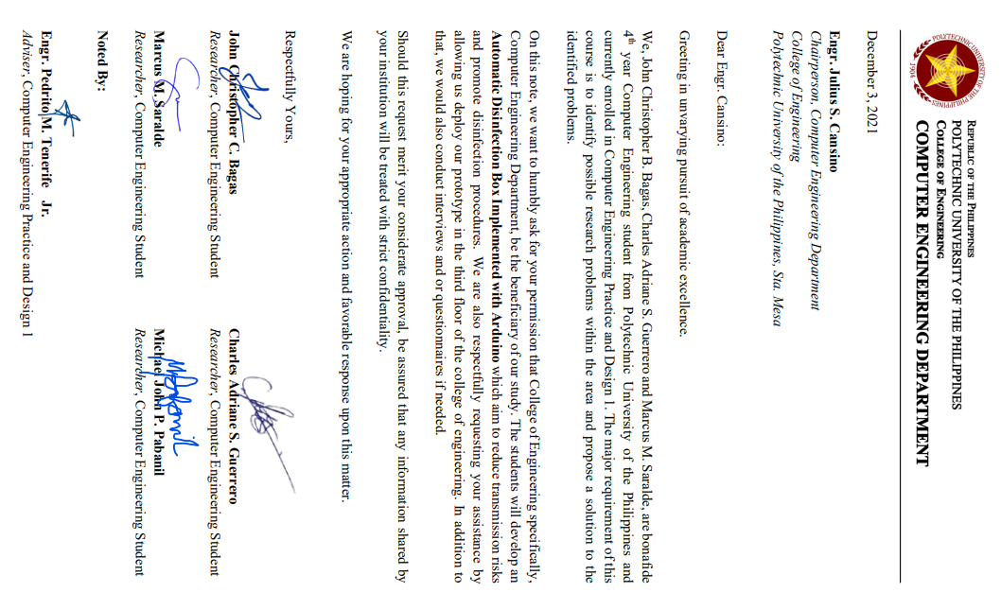

**Appendix 2**

DESIGN PROJECT PROPOSAL DEFENSE 2021

SUMMARY OF COMMENTS

REPORT

**NO.:** CPERC-2021-PROP-POE-R-000060

|  |  |  |  |  |
| --- | --- | --- | --- | --- |
| **GROUP CODE** |  | 3609 | **ADVISER** | Engr. Pedrito M. Tenerife Jr. |
| **SECTION** |  | BSCpE 3-6 |
|  |  |  | | |
| **THESIS TITLE** |  | Development of Automatic Covid Disinfection Box Implemented with Arduino (ADB Automatic Disinfection Box) | | |

|  |  |
| --- | --- |
|  | **NAME OF PANEL** |
| **PANEL CHAIR** | Dr. Remedios G. Ado |
| **PANEL MEMBER 1** | Engr. Arlene B. Canlas |
| **PANEL MEMBER 2** | Engr. Jonathan C. Manarang |

|  |  |  |
| --- | --- | --- |
|  | **COMMENTS** | **RECOMMENDATIONS** |
| **PANEL CHAIR** | Consider the comments and suggestions of the panel of evaluator to improve the project. | think of an alternative application solution to justify the need of this project & with 4 members in a team. |
| **PANEL MEMBER 1** |  | Consider adding how to verify the effectivity/ effectiveness of your disinfection device. Maximize the use of Arduino (example: sending sms about the status of the disinfection and the device) |
| **PANEL MEMBER 2** | Add gsm shield for sending message to the owner of the item being sanitized. Apply this prototype to laboratory subjects, include the counting of object being sanitized. Provide clinical lab test result in front of your subject to denote that it is calibra. |  |

**NOTE:** The data shown above are acquired from the filled-out Panel Evaluation Form in Google Forms. Should there be any error on this report, please notify the CpE Research Committee for verification.

**Appendix 3**

LETTER OF PERMISSION

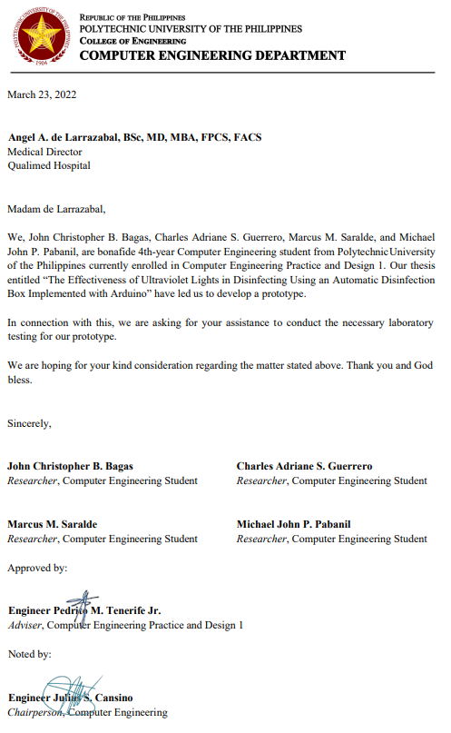

**Appendix 4**

PLANNED DIMENSIONS

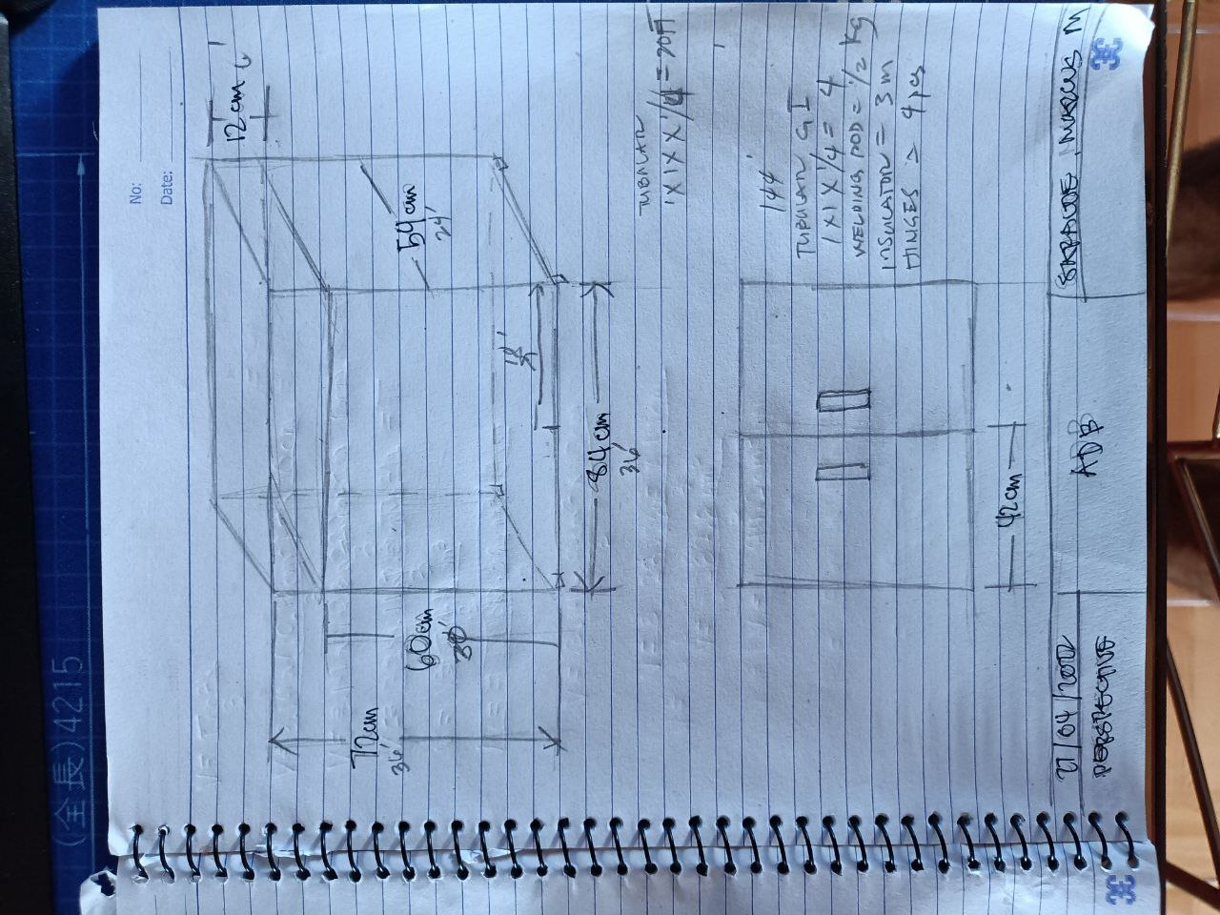

**Appendix 5**

LIKERT SCALE FOR SOP 3A-3B

**SATISFACTION**

1. HOW SATISFIED WERE YOU WITH USING THE DEVICE?
2. VERY DISSATISFIED.
3. SOMEWHAT DISSATISFIED.
4. NEITHER SATISFIED NOR DISSATISFIED.
5. SOMEWHAT SATISFIED.
6. VERY SATISFIED.
7. HOW WELL DOES THIS PRODUCT MEET YOUR NEEDS?
8. IT DID NOT MEET MY NEEDS AT ALL.
9. IT MET VERY FEW OF MY NEEDS.
10. IT MET SOME OF MY NEEDS.
11. IT MET THE MAJORITY OF MY NEEDS.
12. IT MET ALL OF MY NEEDS.

**LOW COST**

1. ON A SCALE OF 1 TO 5, HOW REASONABLY PRICED DO YOU THINK THIS PRODUCT IS COMPARED TO OTHER SIMILAR PRODUCTS?
2. THIS PRODUCT IS NOT A REASONABLY PRICE AT ALL.
3. THIS PRODUCT IS A SLIGHTLY REASONABLE PRICE.
4. THIS PRODUCT IS A MODERATELY REASONABLE PRICE.
5. THIS PRODUCT IS A VERY REASONABLY PRICE.
6. THIS PRODUCT IS AN EXTREMELY REASONABLY PRICE.
7. ON A SCALE OF 1 TO 5, DO YOU THINK THIS PRODUCT IS GOOD VALUE FOR MONEY?
8. I DO NOT THINK THIS PRODUCT IS GOOD VALUE FOR MONEY AT ALL.
9. I THINK THIS PRODUCT IS SLIGHTLY GOOD VALUE FOR MONEY.
10. I THINK THIS PRODUCT IS MODERATELY GOOD VALUE FOR MONEY.
11. I THINK THIS PRODUCT IS VERY GOOD VALUE FOR MONEY.
12. I THINK THIS PRODUCT IS EXTREMELY GOOD VALUE FOR MONEY.

Source Code

Bill of Materials/Costing Correspondence

Instrument Transcription (if applicable)

Certification of Originality Check

Resume

Necessary documents